What is EC2?

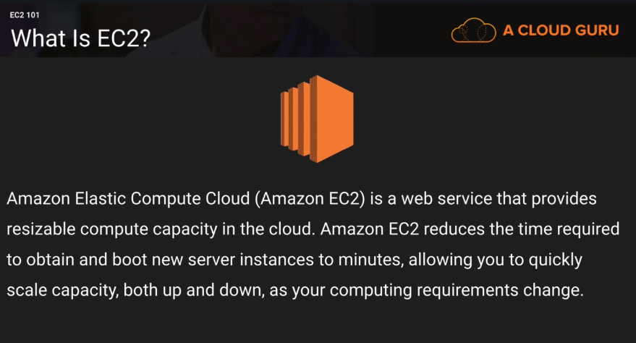

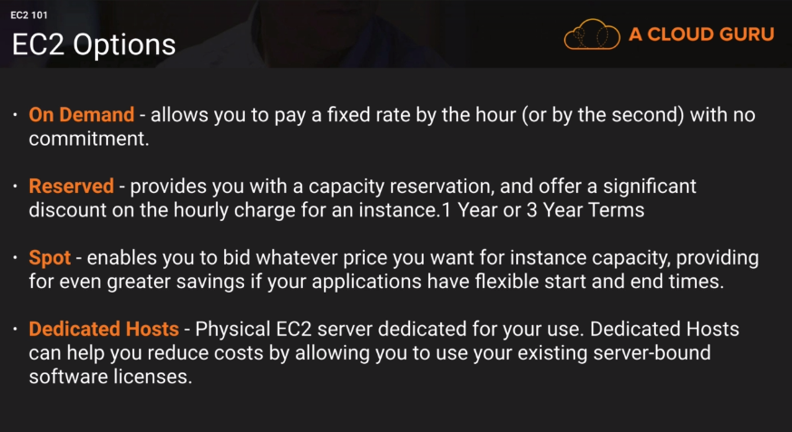

Use cases-

On Demand- users who want flexibility of EC2 without upfront cost, development and testing on EC2, short term applications and unpredictable workloads.

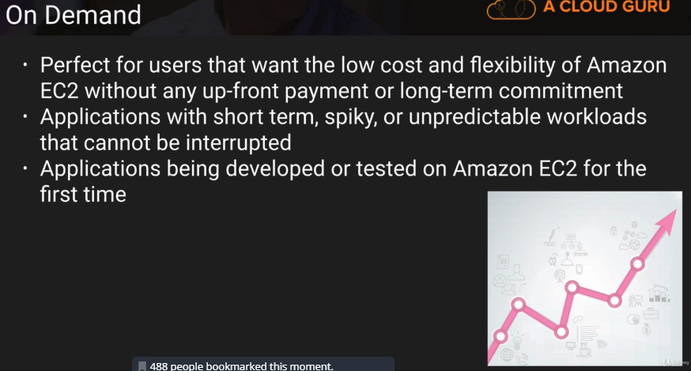

Reserved Instances – steady state applications or predictable usage. Applications that require reserved capacity.

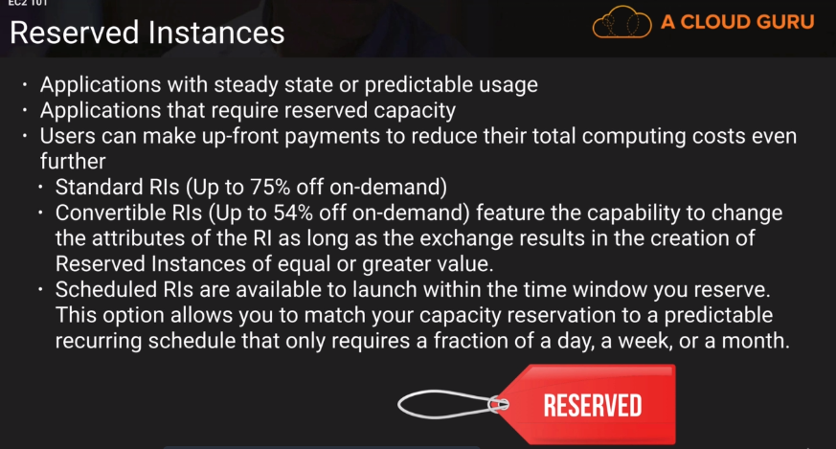

Spot Instances – Applications with flexible start and end times and the applications that are only feasible at a very low compute prices.

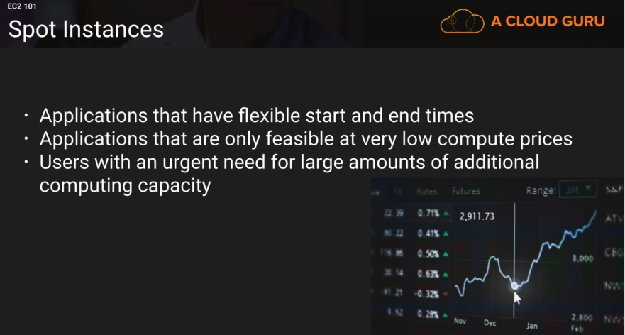

Dedicated Hosts- Regulatory requirements that may not support multi-tenancy.

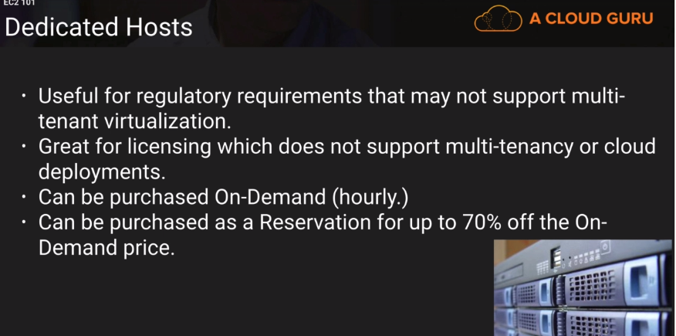

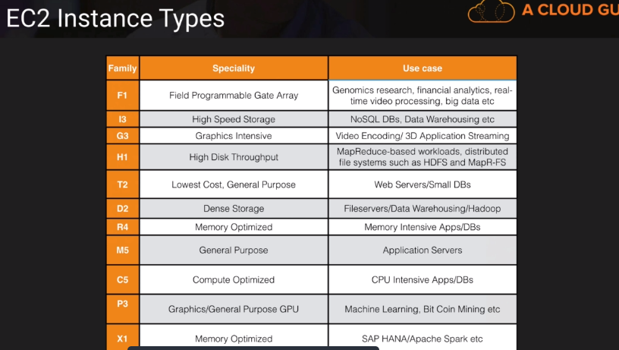

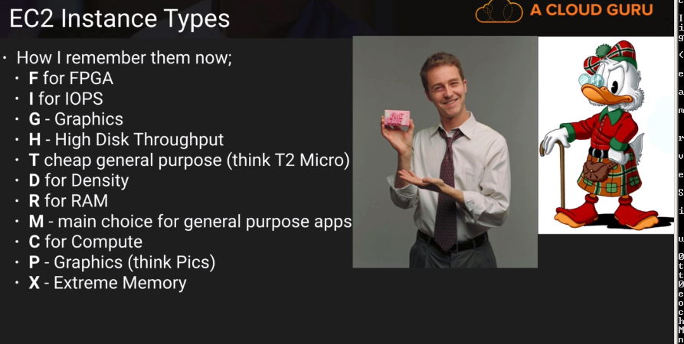

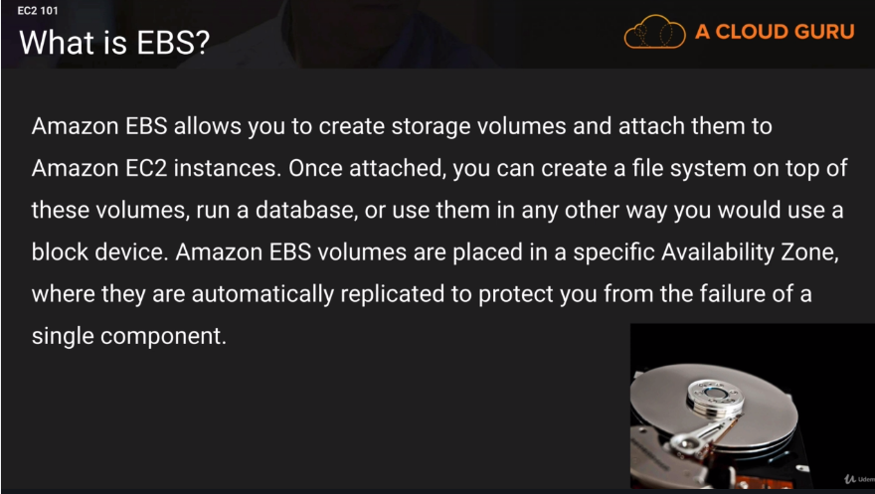

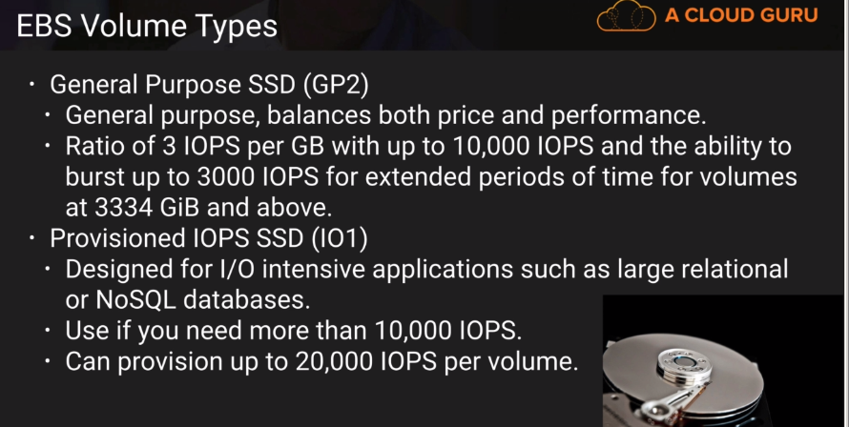

\*\*Anything above 10,000 IOPS is needed, we need provisioned IOPS SSD and anything below, we need General Purpose SSD.

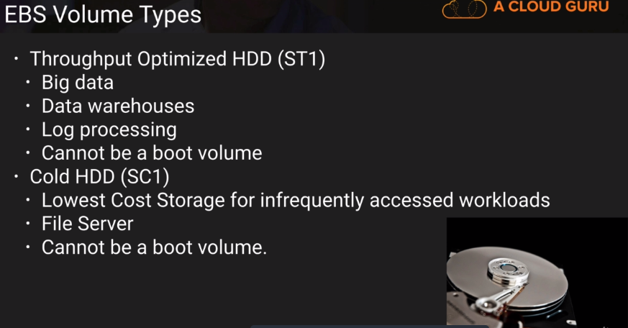

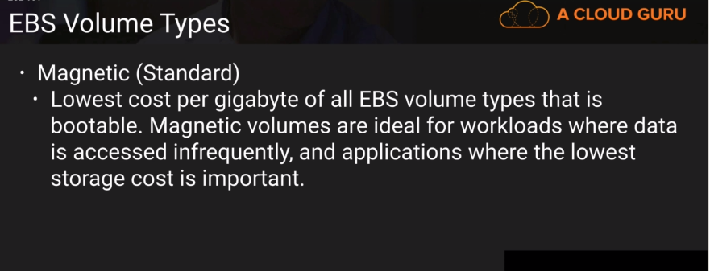

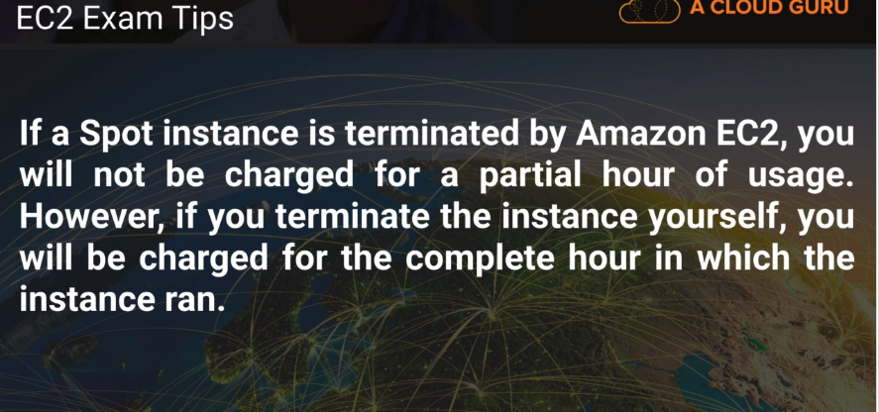

Lab –

Go to EC2 service and click on launch instance.

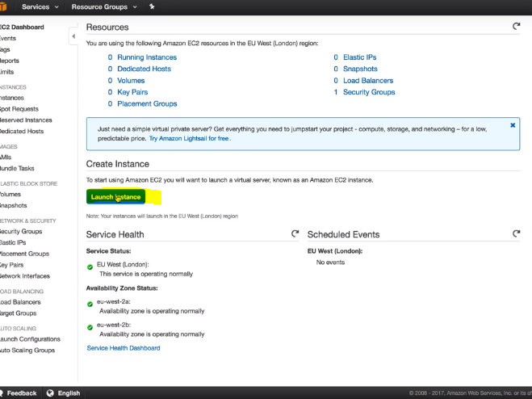

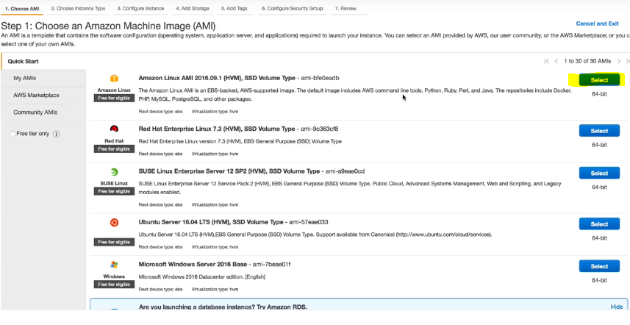

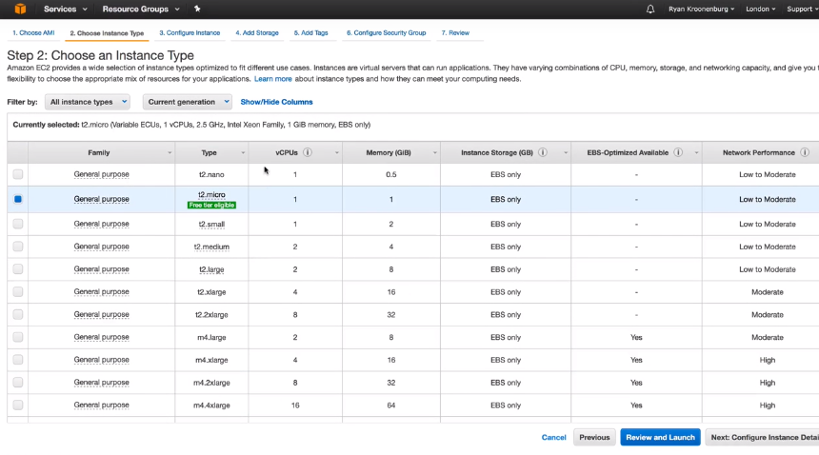

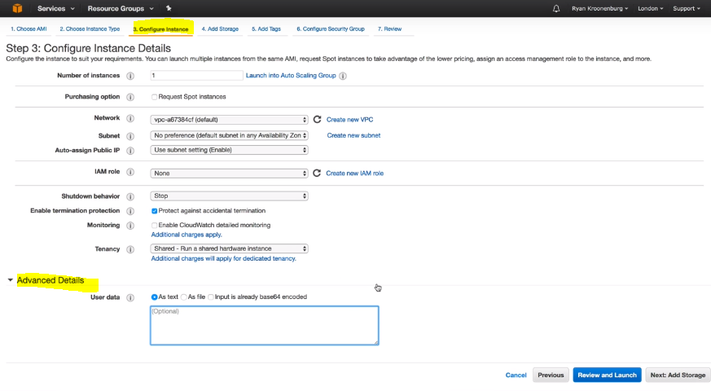

In the configure instance, we can specify the VPC, subnet and IAM role. For now we are leaving them to the default value.

In the additional details, we can specify the bootstrap codes.

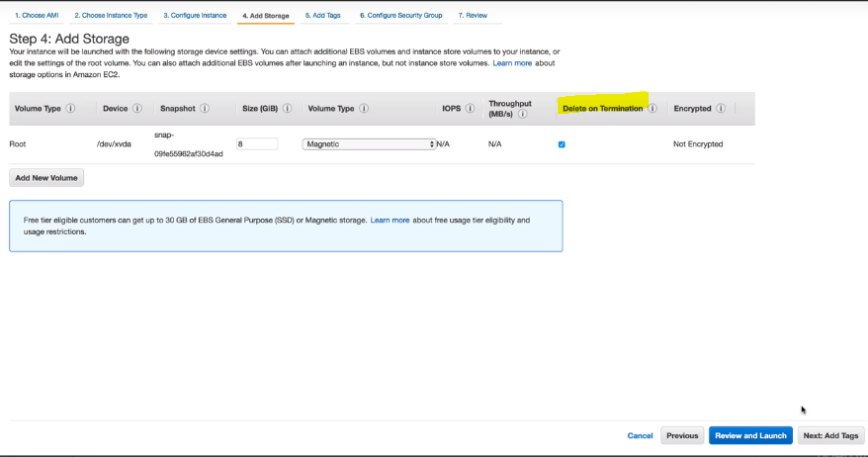

In the Add storage, we are leaving everything default. We can add additional volume, EBS with any kind of volume type. It is important to note that the Delete on Termination is checked which means that the volume will be automatically deleted when the EC2 instances are terminated.

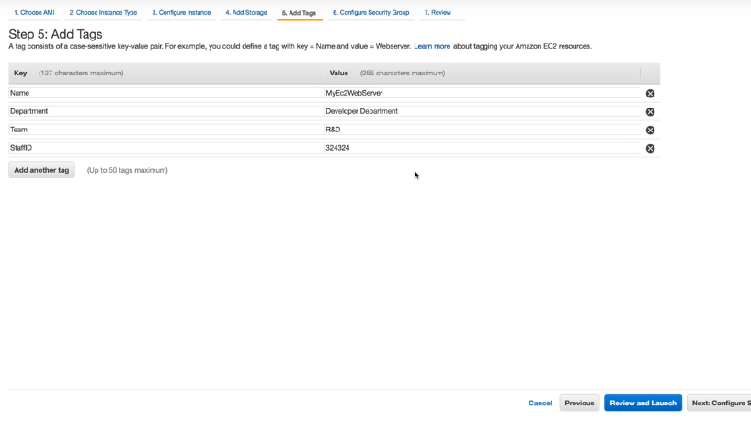

Tags help us in saving cost. So, the best practice is to use as many tags as possible.

The Name tag gives the name of the webserver.

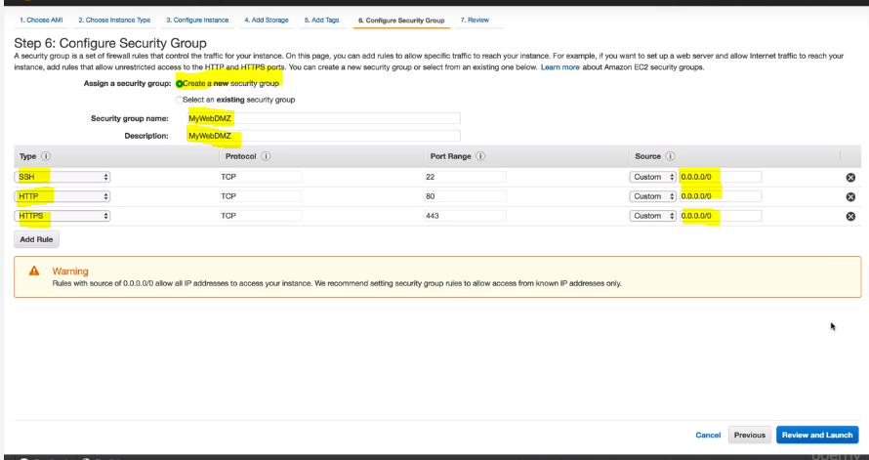

Create a new SG if the SG do not exist already. Give it a name and description. Add rules to it.

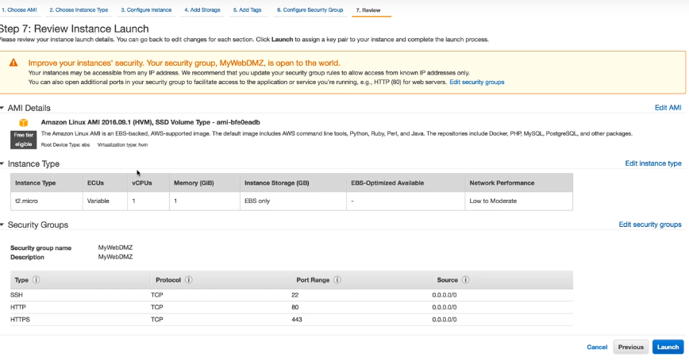

Review all the configurations made by you and click on launch.

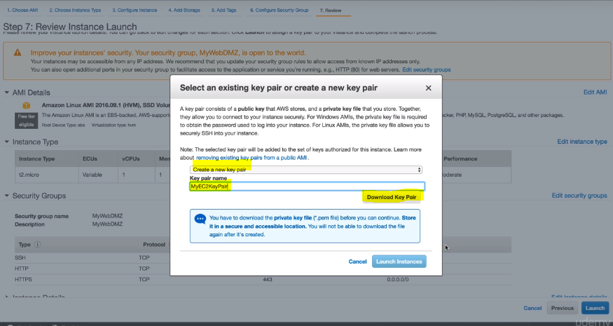

We will have to create a key pair at the time of launch. This is the private key. Amazons maintains the public key and we have the private key with which we can connect to the instance.

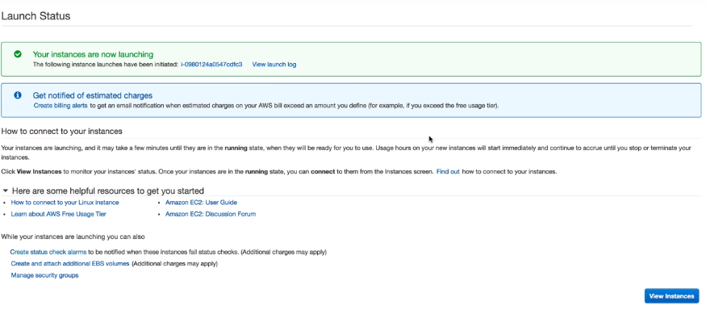

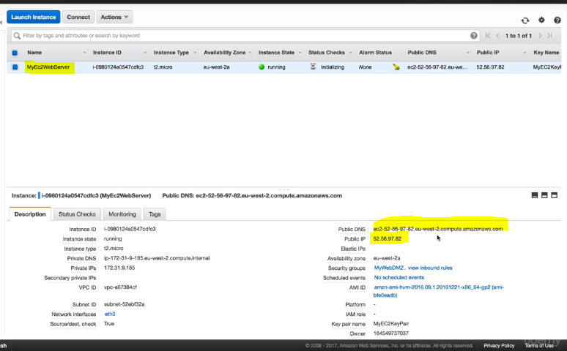

The name is the same as we defined in the tag while setting it up.

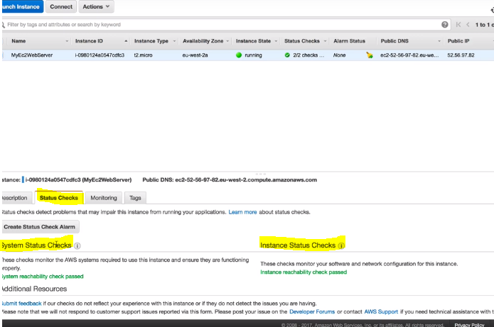

There are two types of status checks- System status checks and Instance Status Checks.

System status checks is the checks of the health of the hypervisor underneath.

Instance status checks is the check of the traffic in the instance.

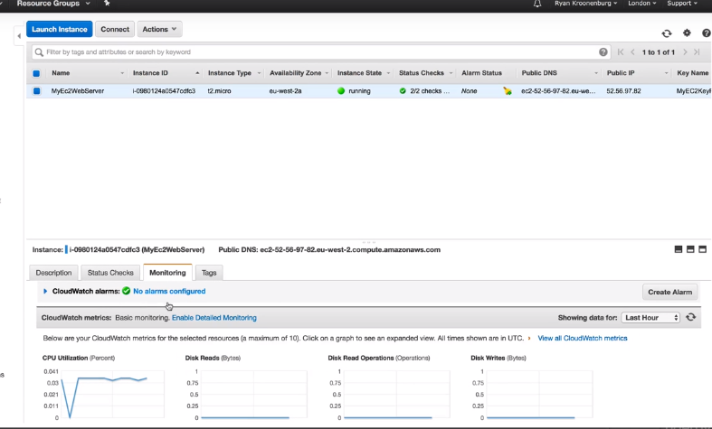

The basic monitoring is every five minutes by pinging the device.

Windows user need putty and puttykeygen to connect to linux instances. Putty ony accepts .ppk files and security key created is of .pem type. So, putty keygen is used to convert it to .ppk.

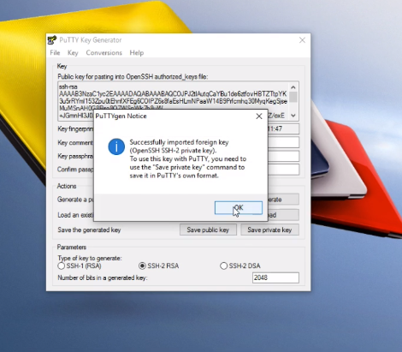

Load the .pem file to putty keygen.

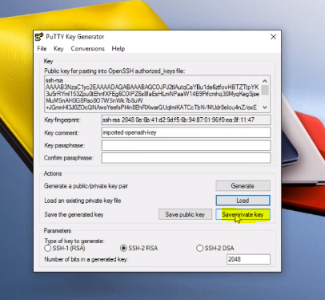

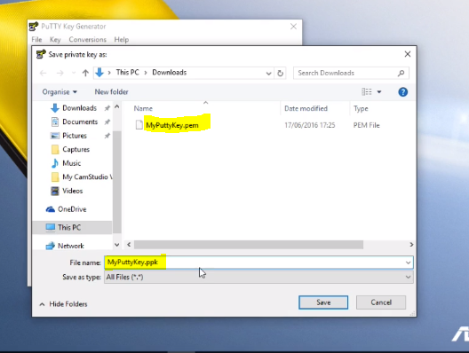

While saving, maintain the filename just change the extension.

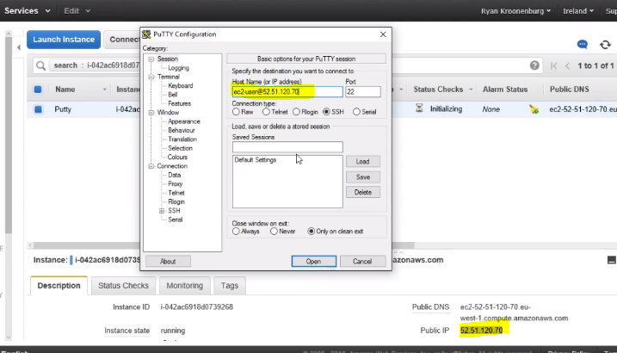

Once the key is created, open the putty and give the hostname as ec2-user@publicIPofInstanceCreated

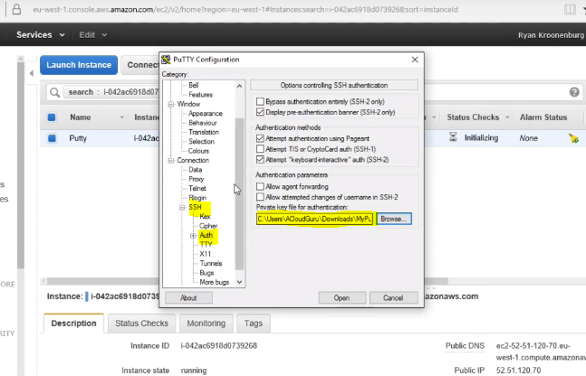

In the SSH tab select Auth and browse the public key.

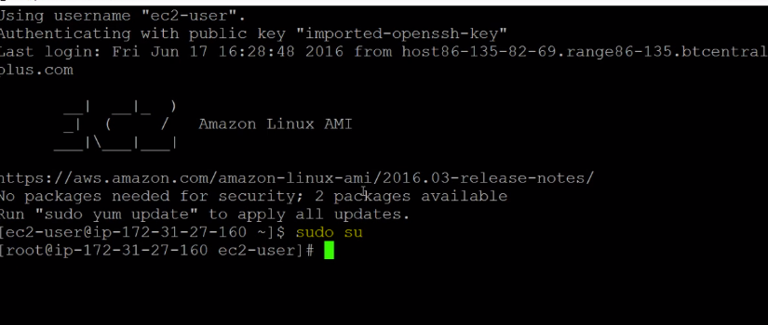

Yum update -y

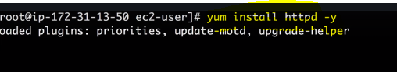

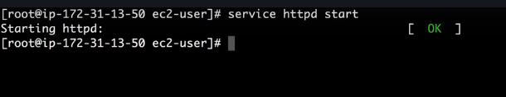

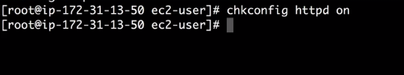

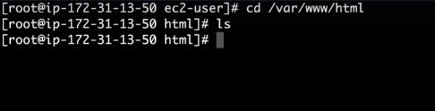

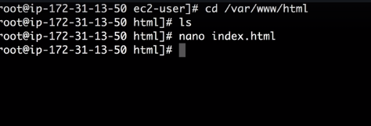

In the web browser, browse the public IP.

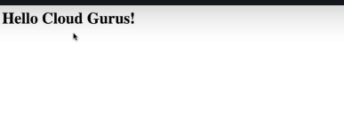

\*\*Using the default setting, we cannot encrypt the root volume but any additional volumes can be encrypted.

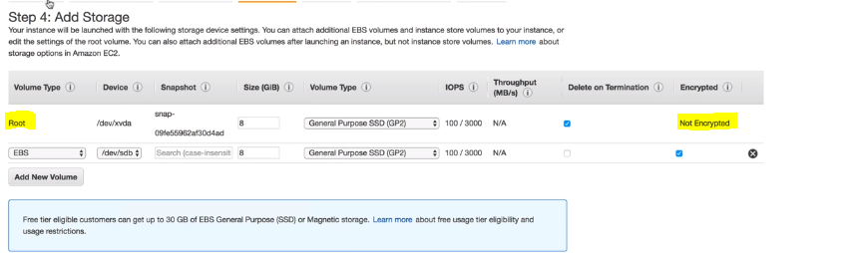

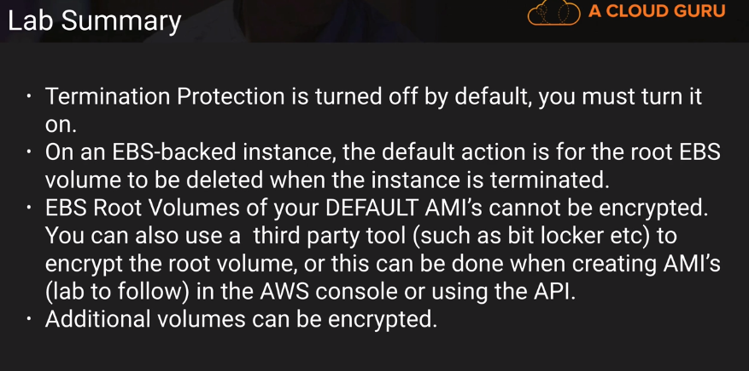

Security Groups,

\*\* Any rule change you make in the SG, it will be affected immediately.

\*\* They are stateful. So, any rule added to the inbound, will be automatically be added to the outbound as well

\*\* We cannot specifically deny traffic in SG. Everything by default is denied, we just allow the traffic.

\*\* The default traffic is having all traffic allow inbound and outbound.

\*\* One instance can have more than one SG as there will be conflicts in the rules as they can just allow the traffic.

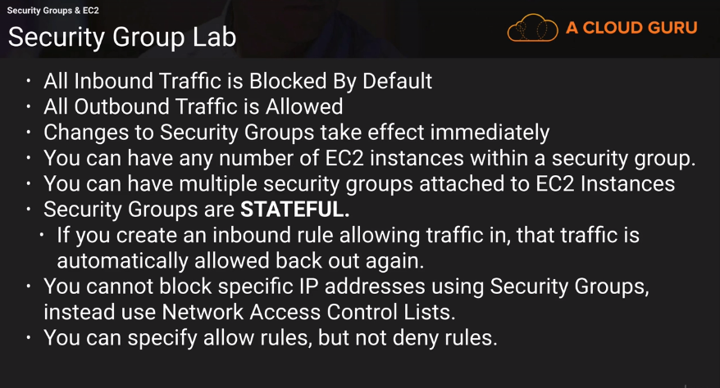

EBS Volume Lab-

Create an EC2 Instance with the multiple storage options.

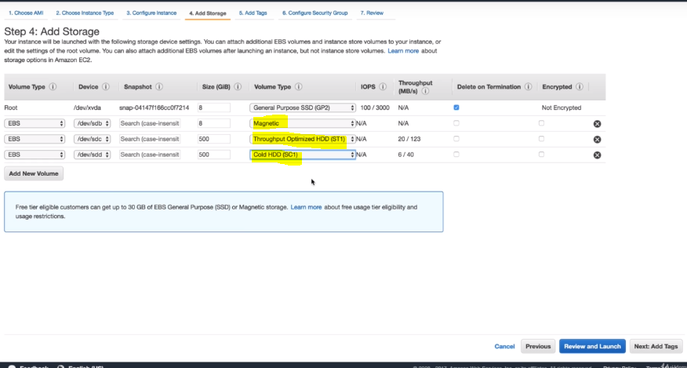

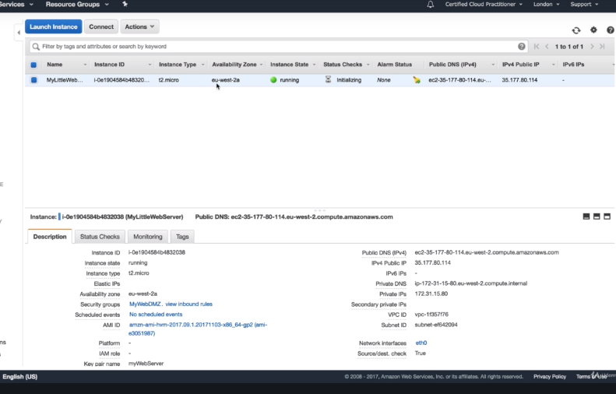

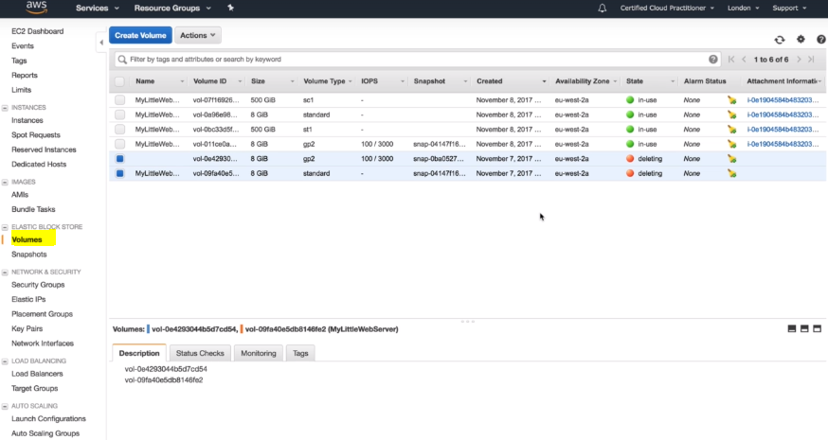

When you go to volume tab, you can see all the volumes created by us.

\*\* The EBS volume can be only mounted in the AZ zone where our EC2 instances are running.

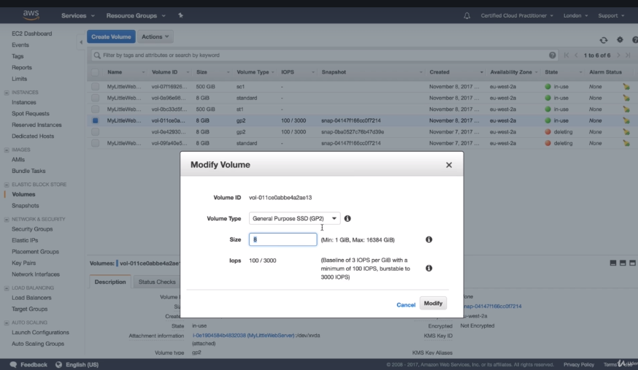

\*\*You can modify the volume on the fly and there will be no downtime.

\*\* Standard volumes are magnetic which cannot be modified.

To create the EBS Volume in another AZ, we need to take its snapshot first.

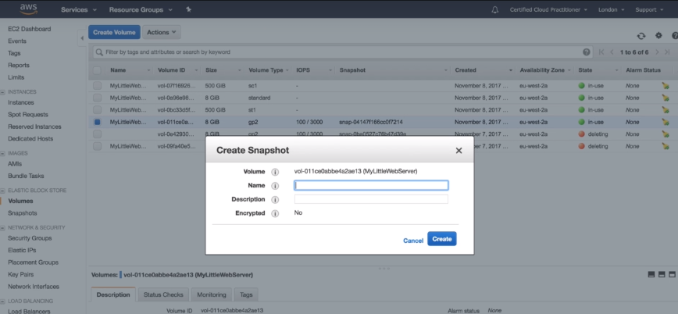

When you go to the snapshot tab, you can see the snapshot created. Using it, you can create an image or volume.

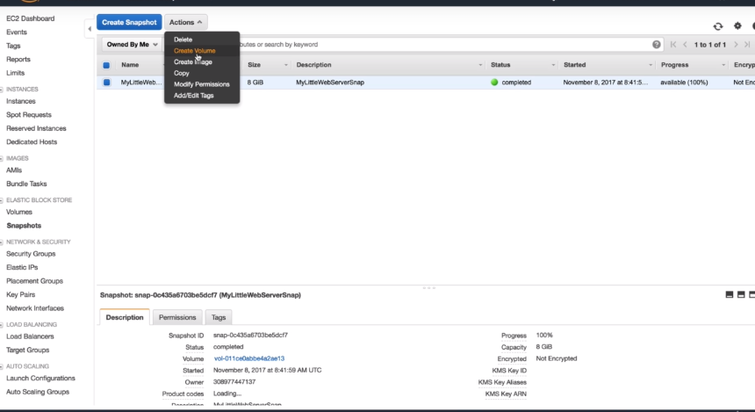

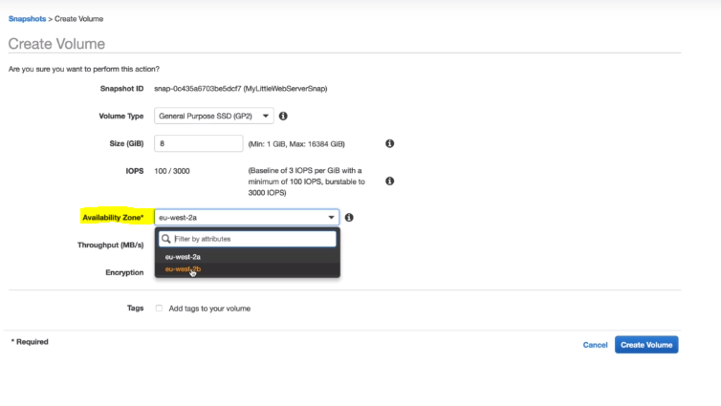

Copy snapshot will allow you to move the snapshot in other region.

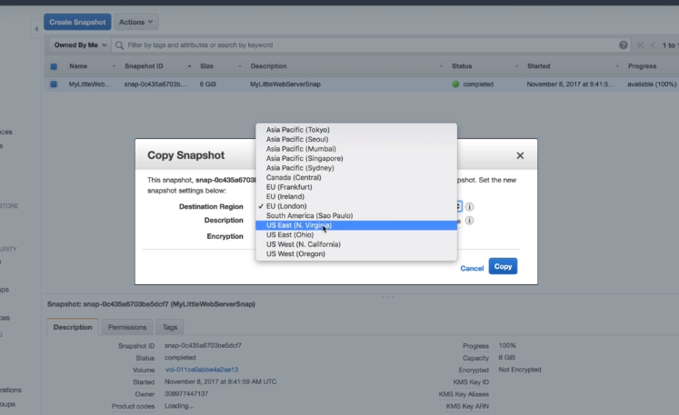

When you create an image, you will be able to boot it like a new EC2 instance.

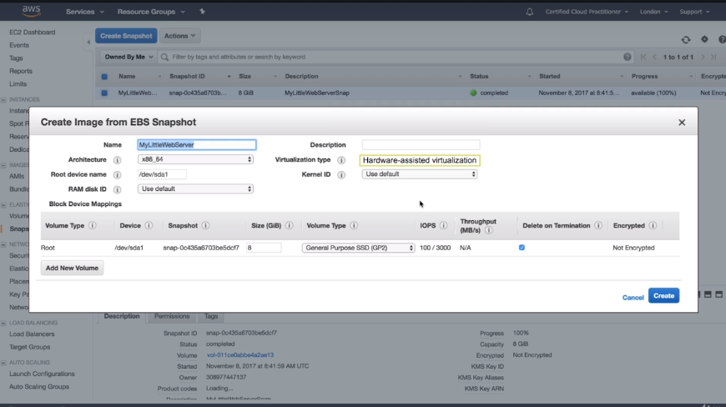

Snapshots are used to backup and images are used to launch EC2 instances.

In the AMI, you can see an image is create in 5 mins.

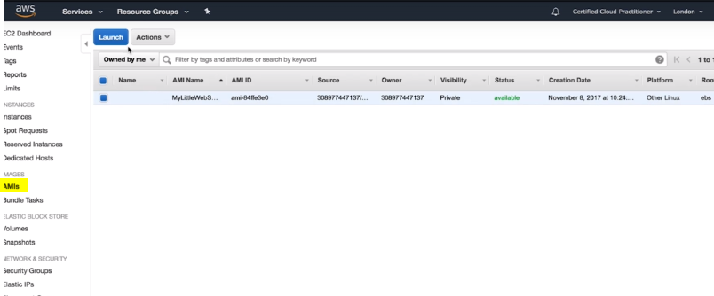

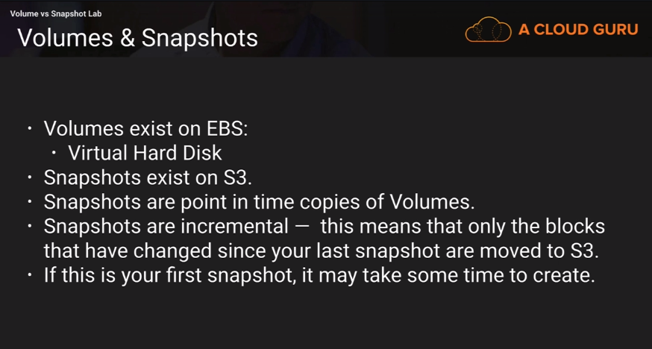

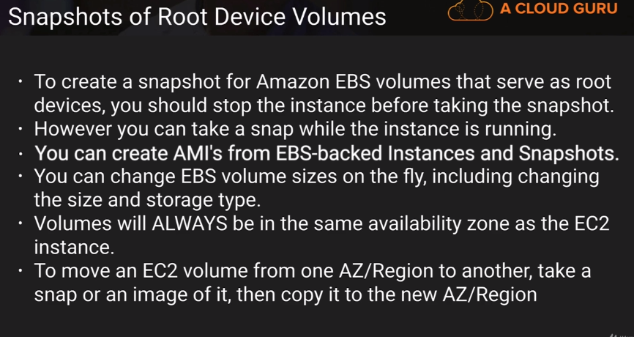

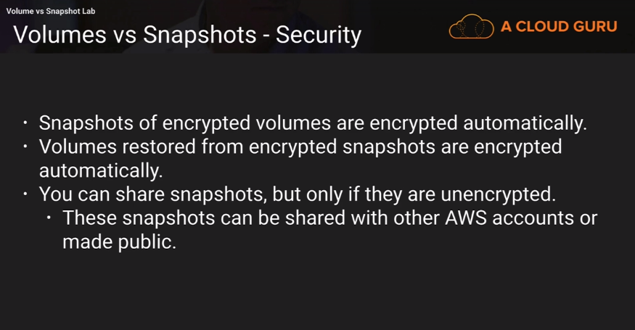

RAID, Volumes and Snapshots-

When you are not getting the disk IO that you require, you add multiple EBS volume and configure them as RAID array.

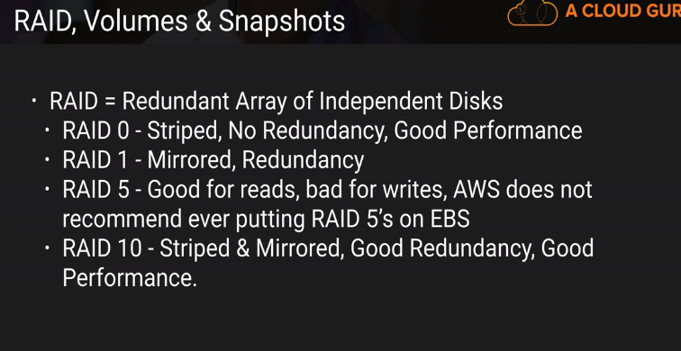

Lab-

Go to EC2 service, we will create a windows instance.So, the SG we are using should have RDP in its inbound rule.

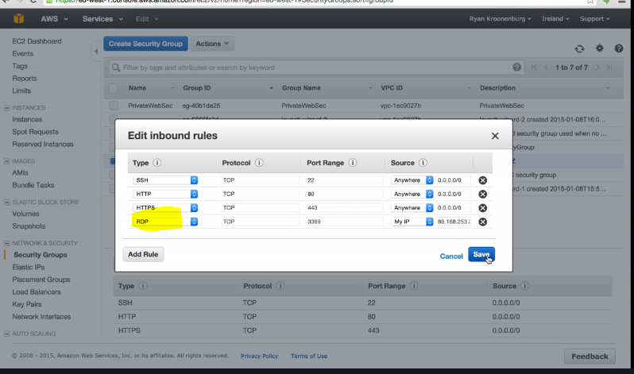

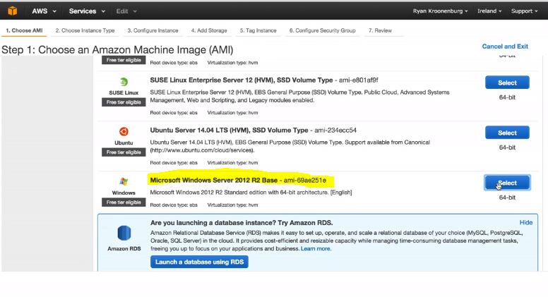

Add 4 General purpose SSD volumes.

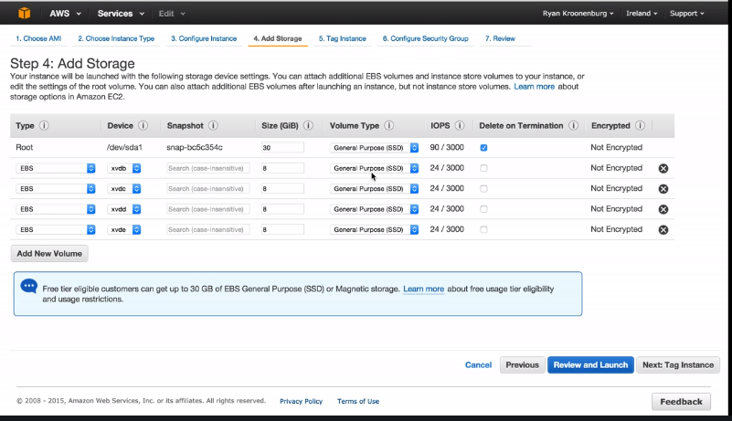

Select the SG which we have already created,

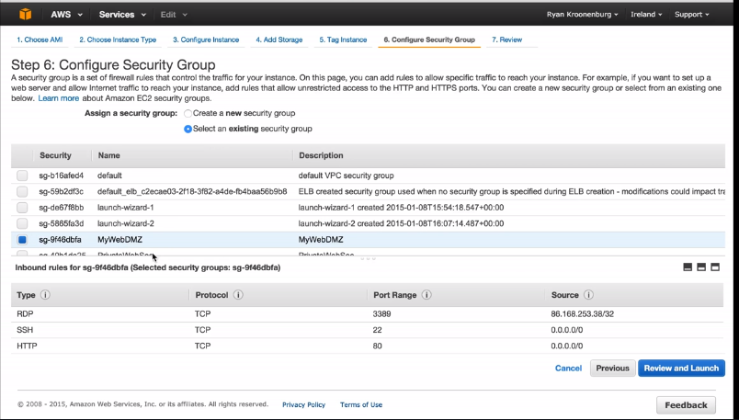

Create the key/pair,

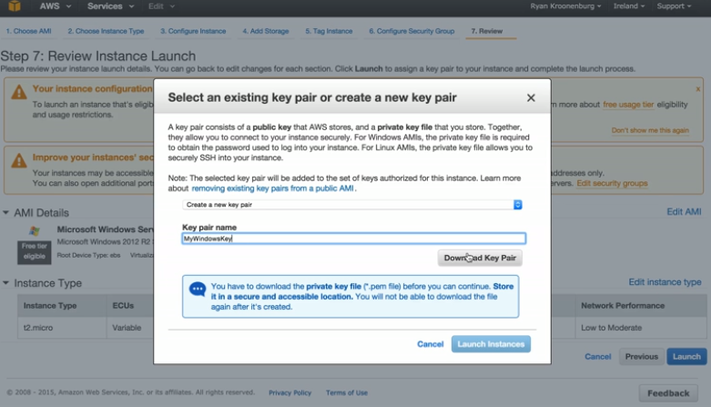

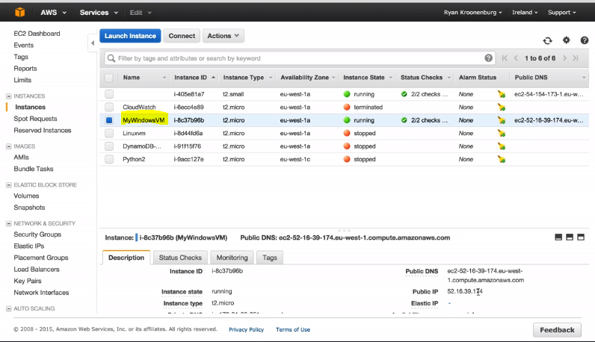

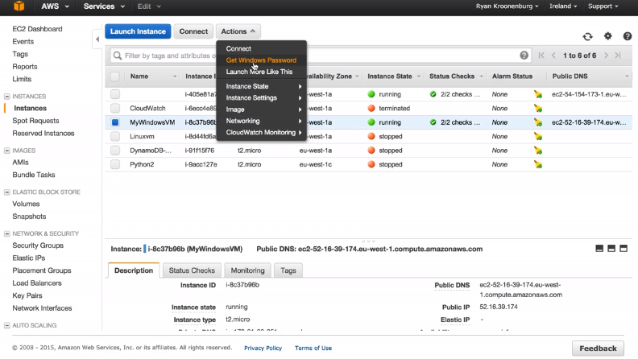

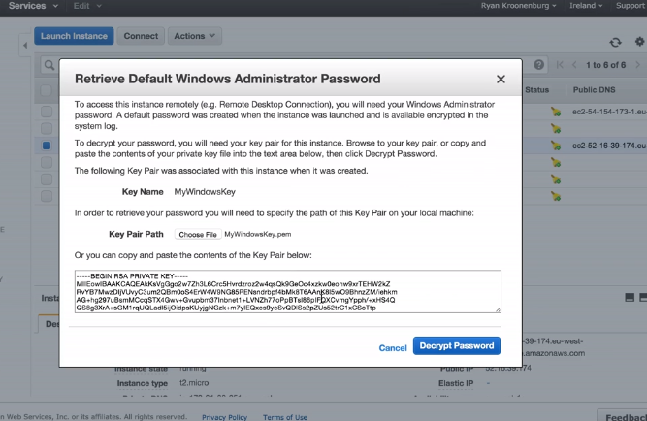

Password will be generated for RDP,

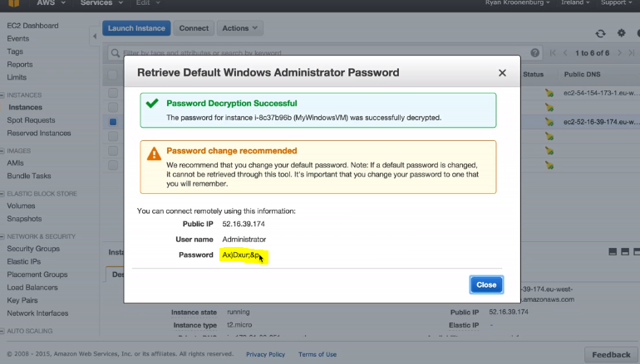

RDP(run->mstsc) to the public IP address of the windows instance using the above credentials,

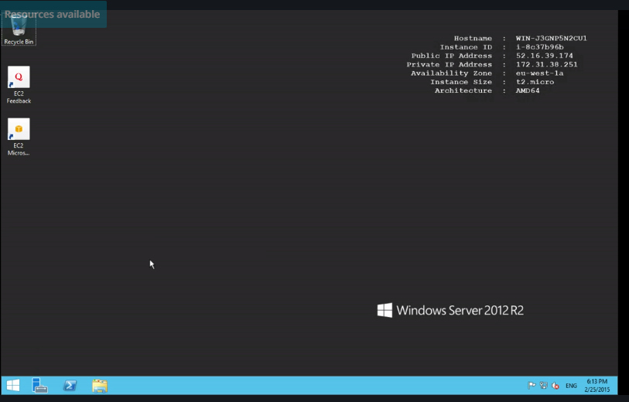

You can see the additional volumes that we have created,

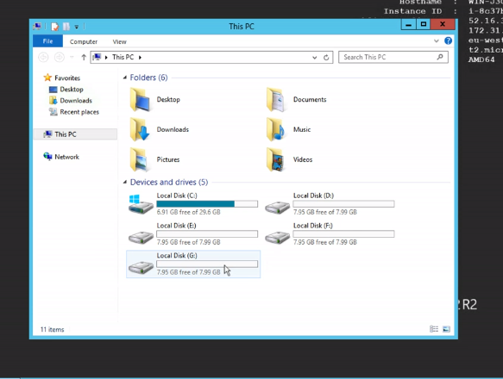

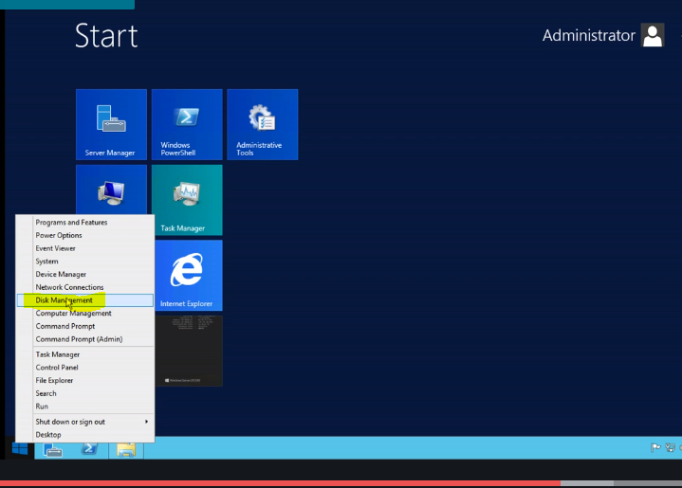

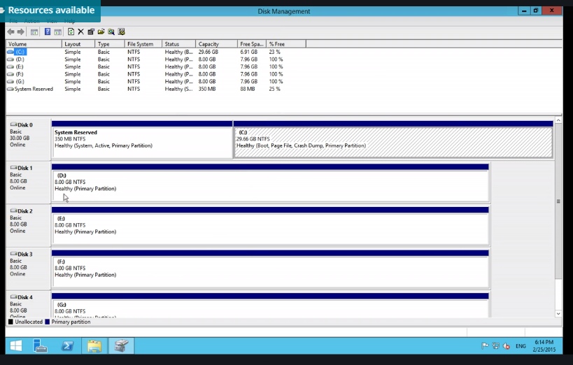

Right click on first volume and select delete volume,

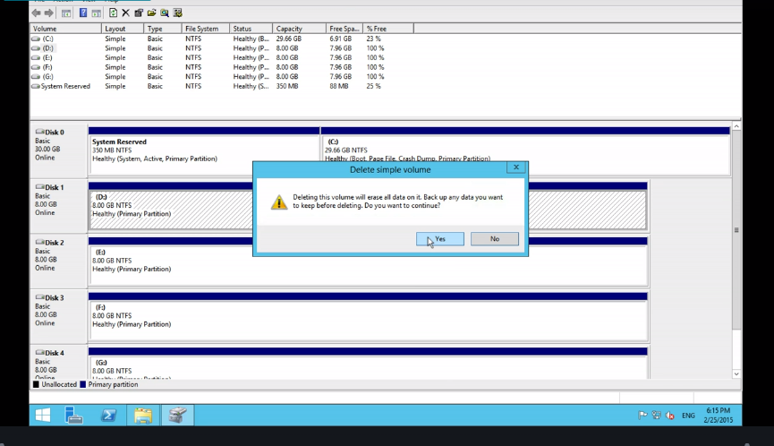

Do the same for all the volumes.

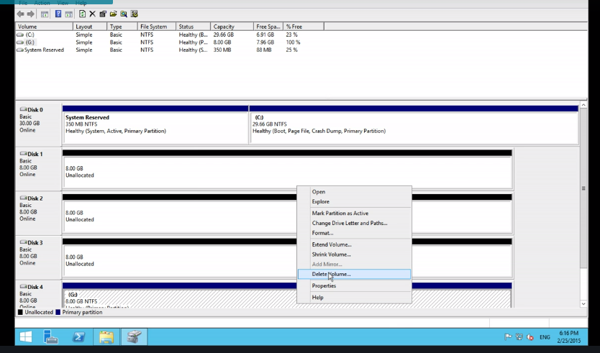

Right click on the unallocated volume and select the striped volume.

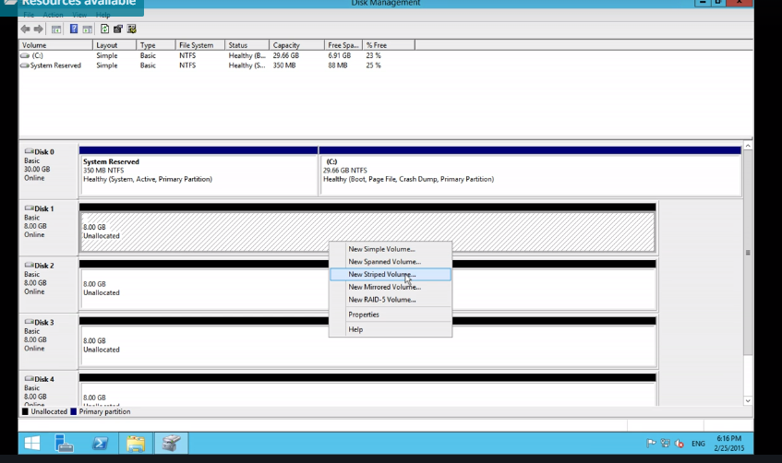

Add all the available disks.

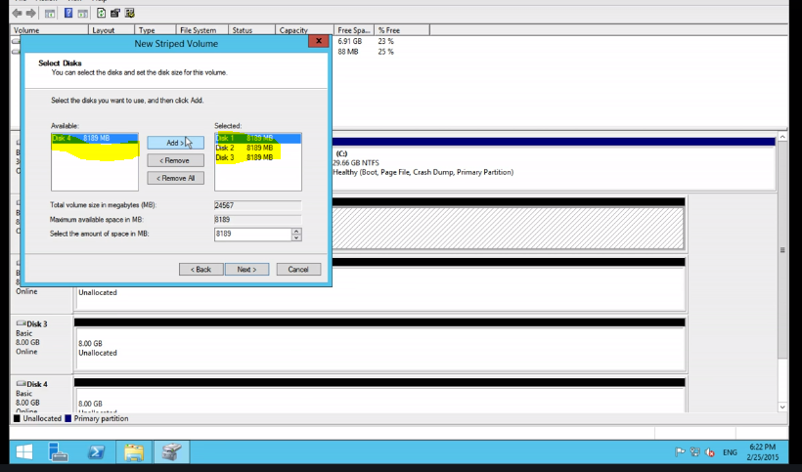

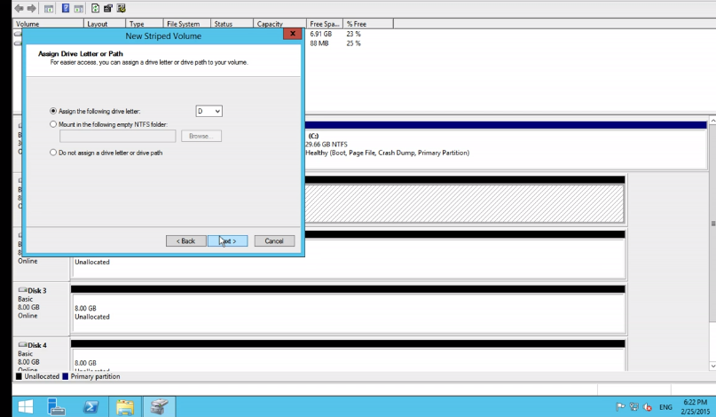

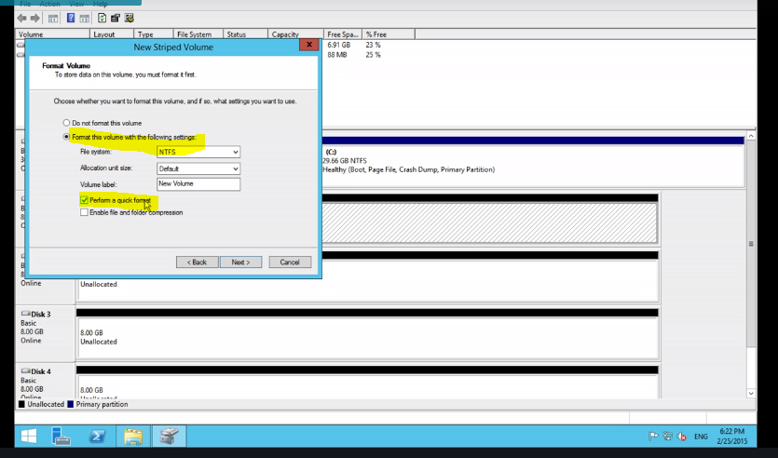

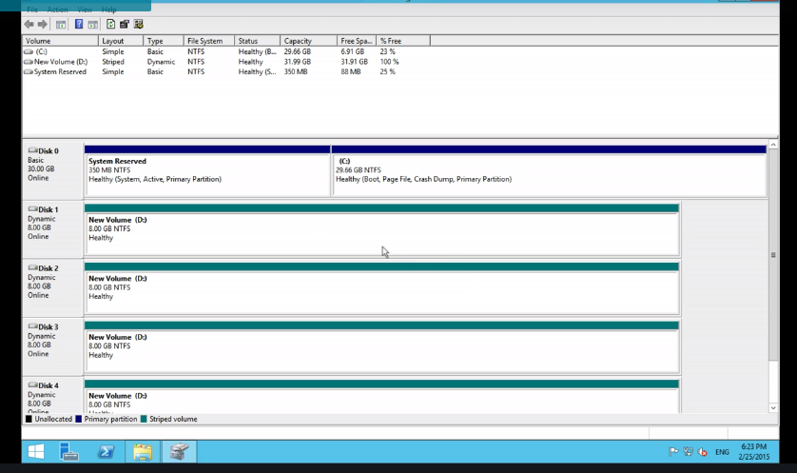

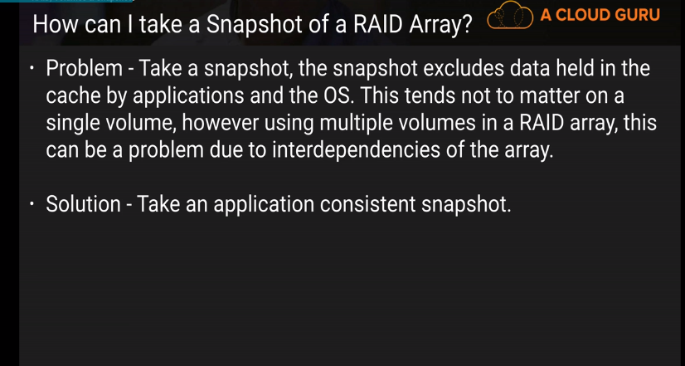

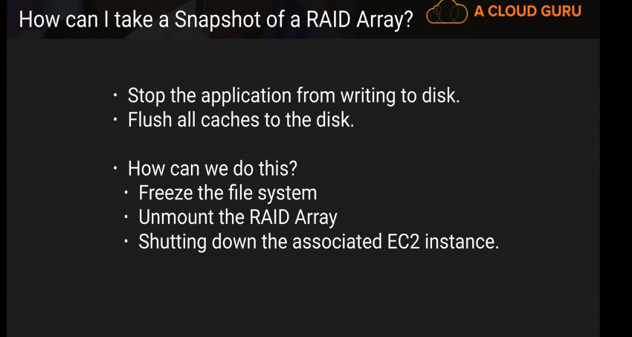

How to create an ami,

Stop the running instance 1st,

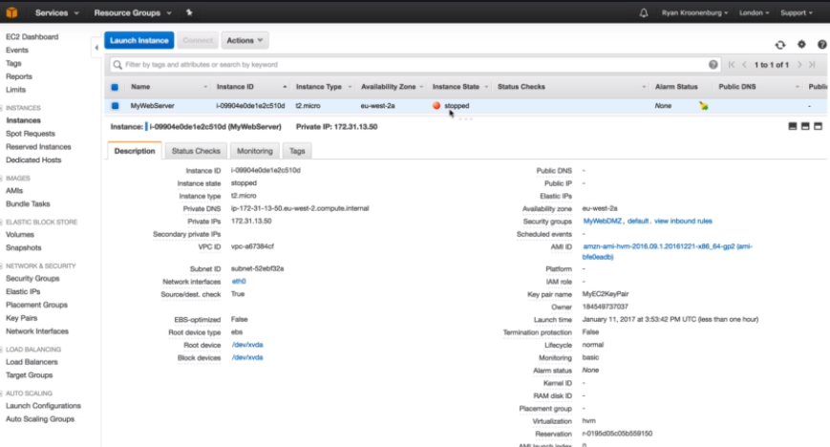

Go to volumes,

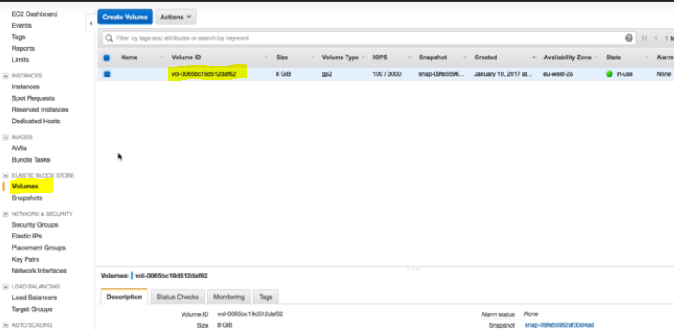

Go to actions and select crete snapshot,

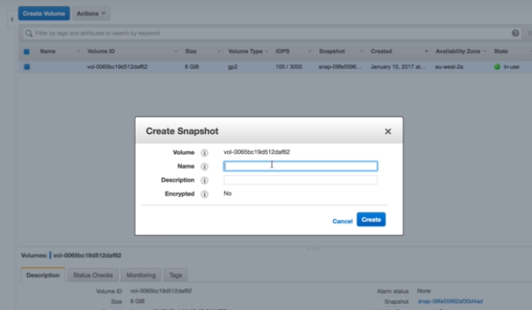

You can see the created snapshot in the snapshot tab,

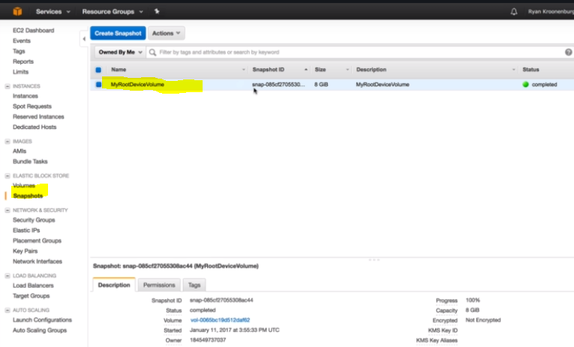

We can copy the snapshot to different regions,

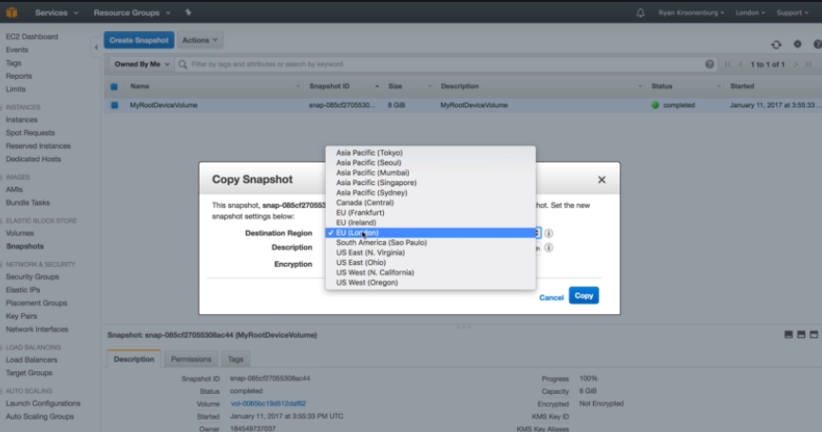

You can create the image of the snapshot, we can use this to boot our EC2 intances.

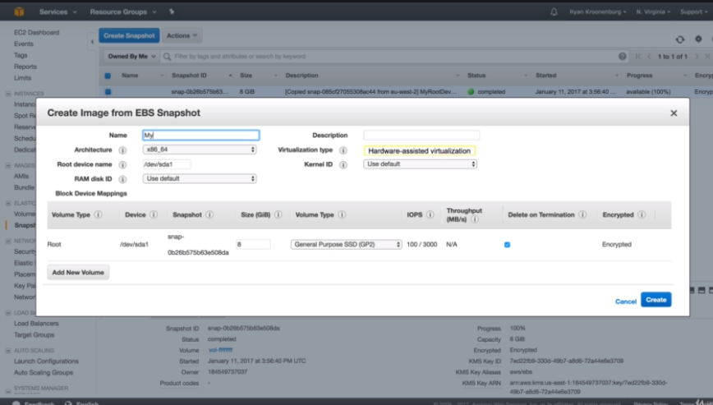

In the ami tab , you can see the image created,

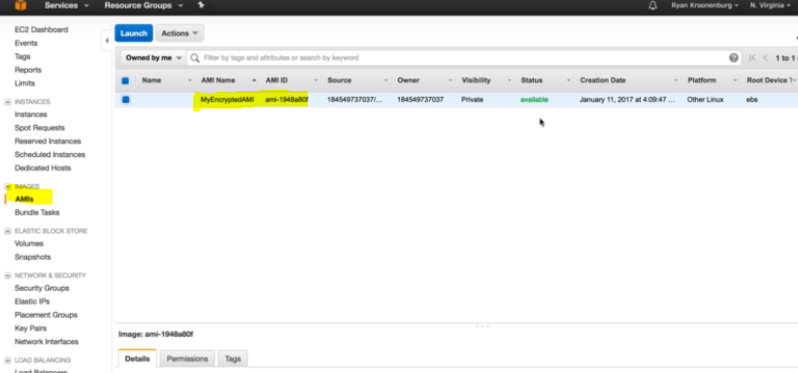

Click on the launch tab in the previous picture and launch an instance, you can see the same storage in the root volume of the instance being created.

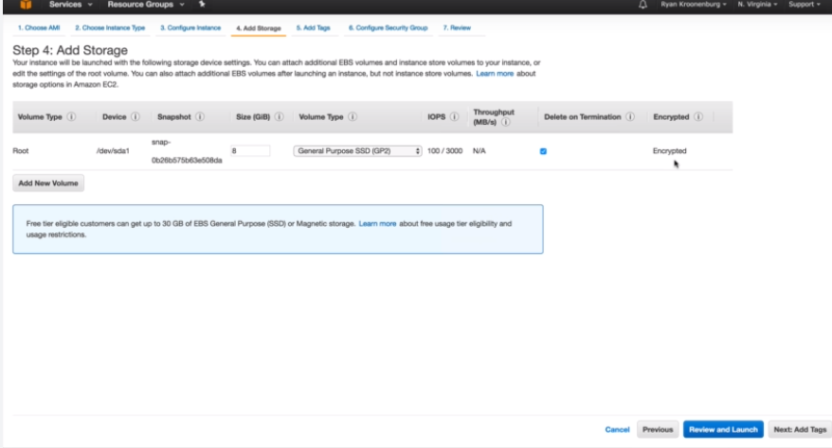

Deregister your AMI after use.

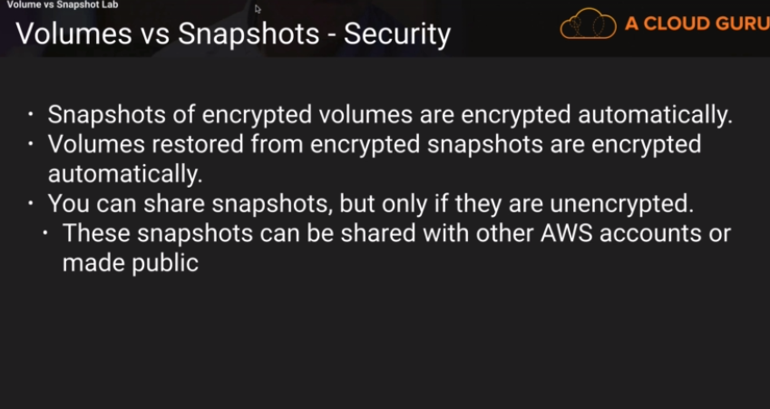

EBS Root volume and Instance store-

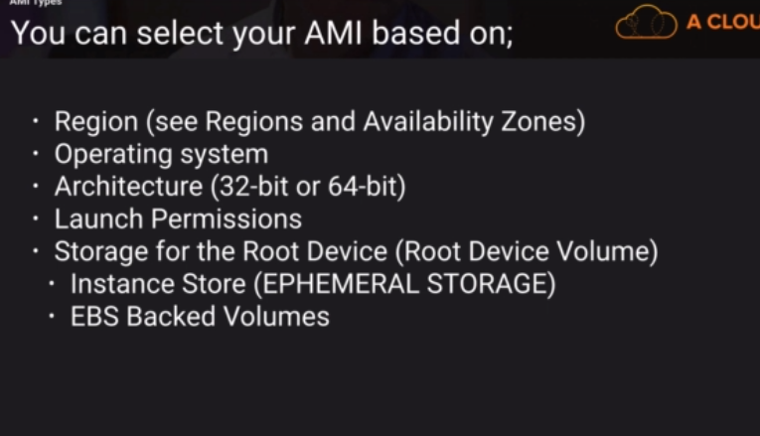

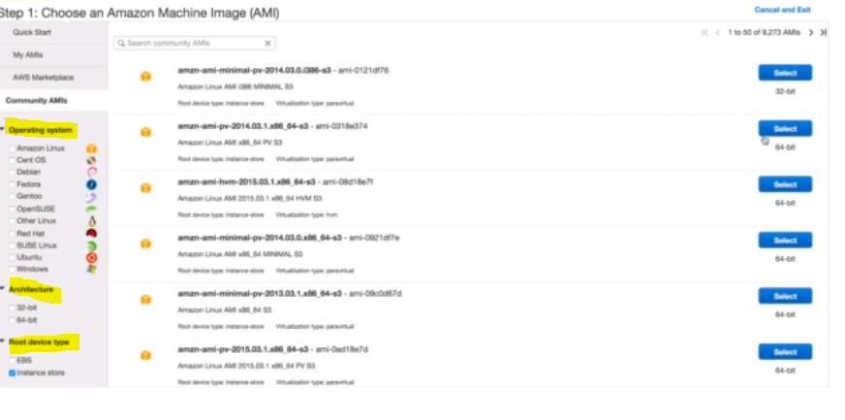

Launch a normal linus instance with the EBS volume root device type like before.

And another of Instance store root device type.

Launching instance of Instance store type storage,

Go to community ami and select the below highlighted ami,

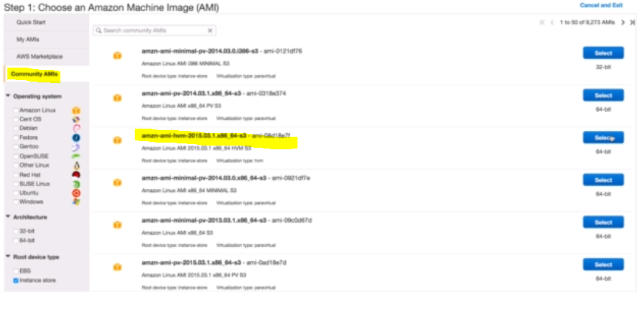

Select m3 medium instance type,

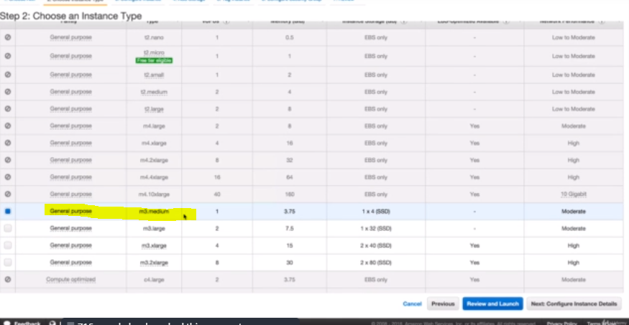

\*\*At the add storage step, you can add more instance store volumes and EBS volumes. But we cannot attach more instance volumes once the instance is created.

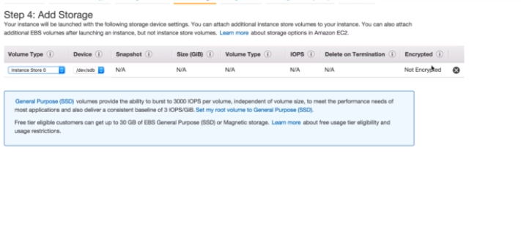

We have both the instances launched,

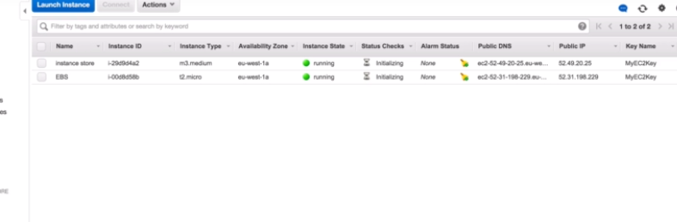

With the EBS instance, we can stop the instance. But with the instance store instance, there is no option to stop the instance. There in an option to either reboot or terminate.

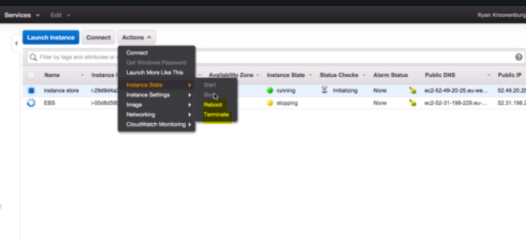

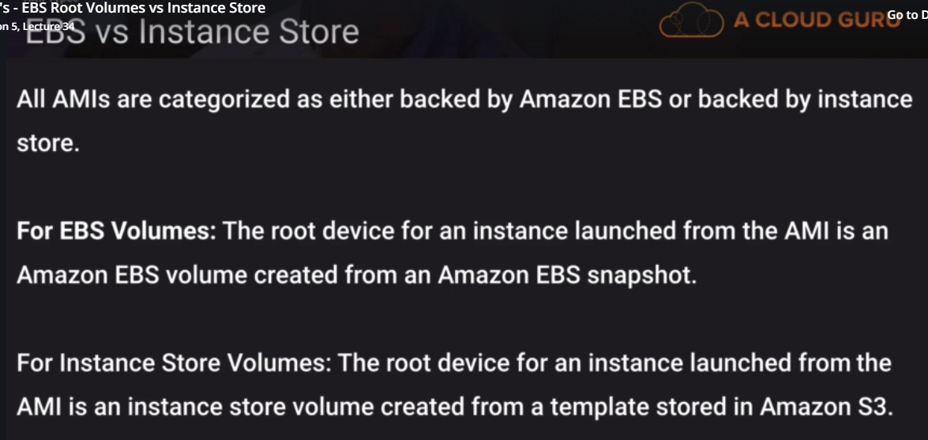

Instance store volume takes more time to be launched. Id you want to speed up the process you use the ami backed up by the EBS volume.

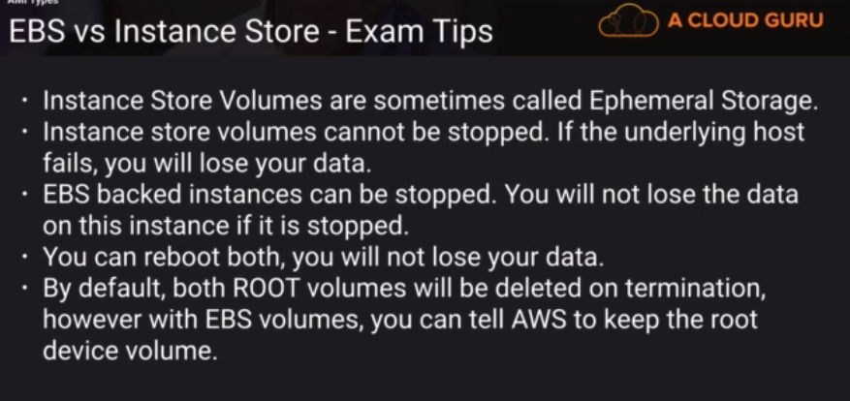

If the underlying host fails in EBS volume instance, you can stop the instance and change the underlying HVM and start the instance again, but we cannot do the same with the instance store type and will loose the data.

Elastic load Balancer – Balances the HTTP traffic you are getting for the webservers.

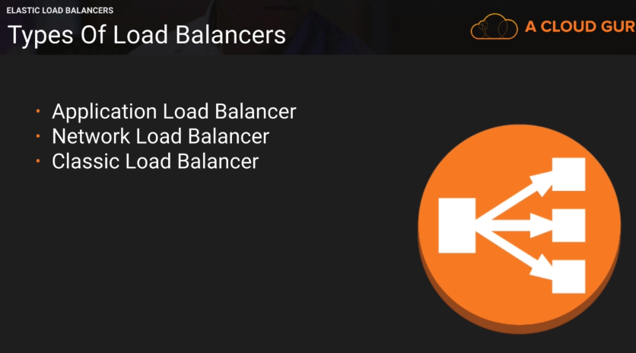

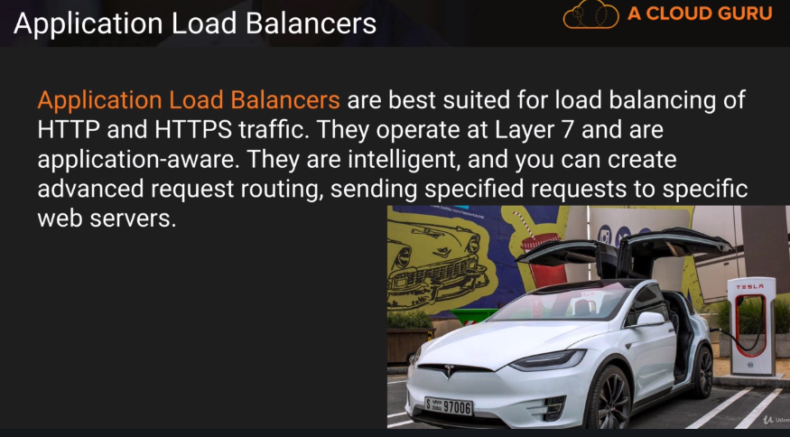

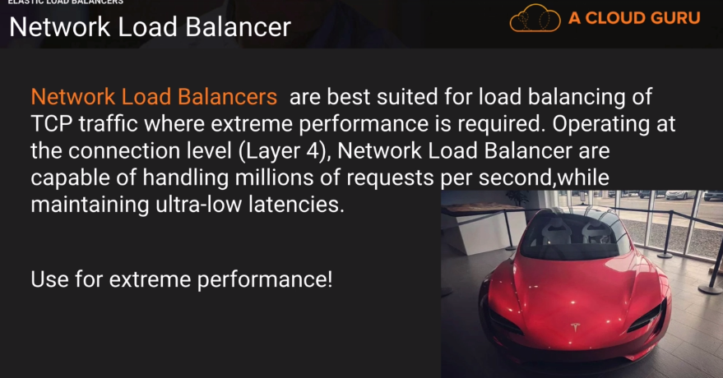

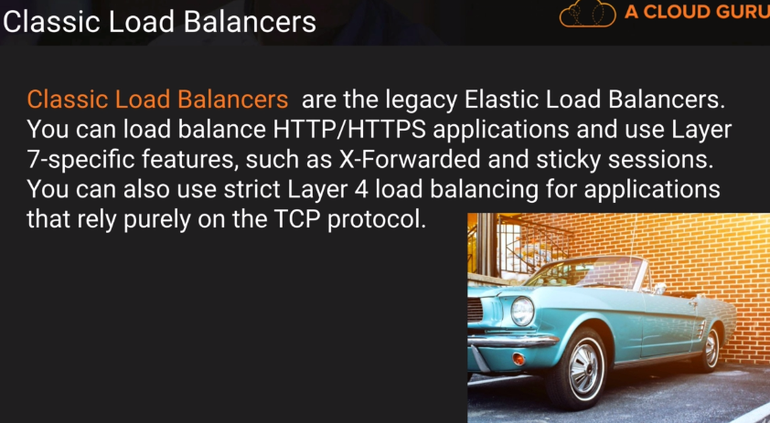

Best practice to use either network or application load balancers.



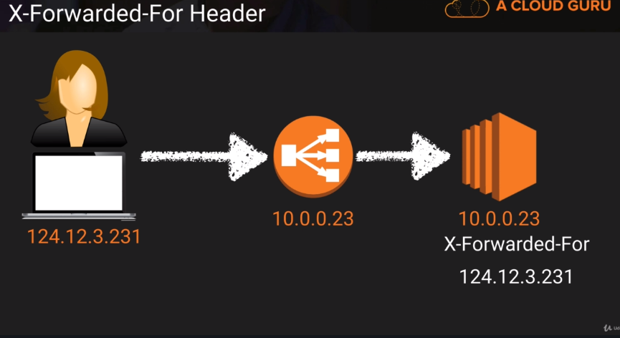

124.12.3.231 is the public IP address and 10.0.0.23 is the private IP address of the load balancer. EC2 instance will only see the private IP address and get the public IP address of the user for X-Forwarded-For Header.

Public IP(IPV4 address) address reveals a lot of information about the use like from where the user is logged in and which organizations are using your website etc.

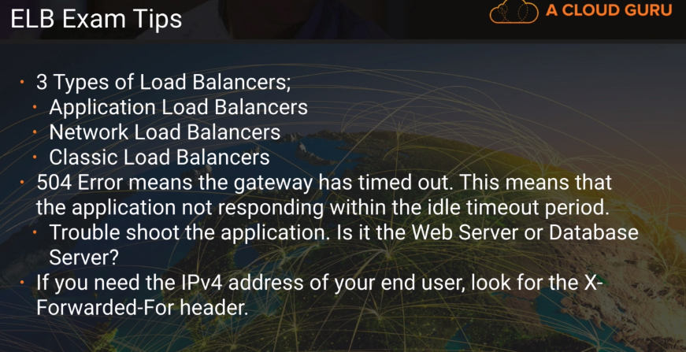

Load Balancers and Health Checks-

Create classic load balacers-

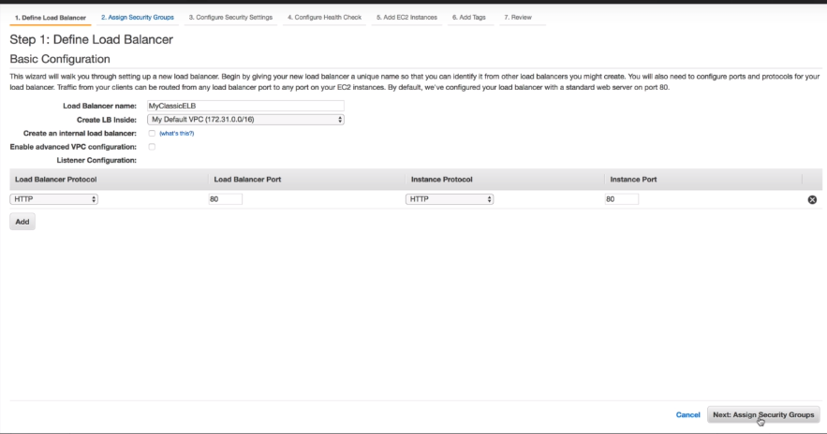

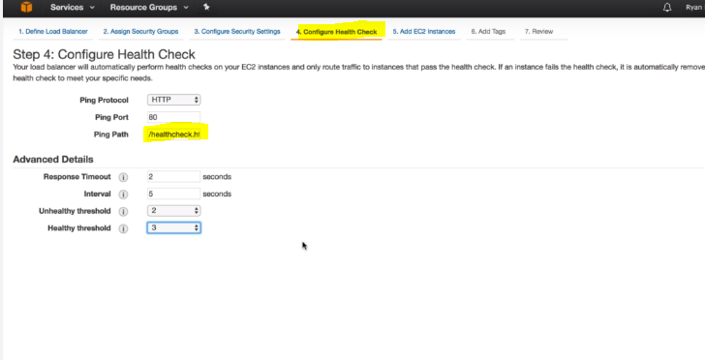

You need to create the ping path in /var/www/html in the instance created.

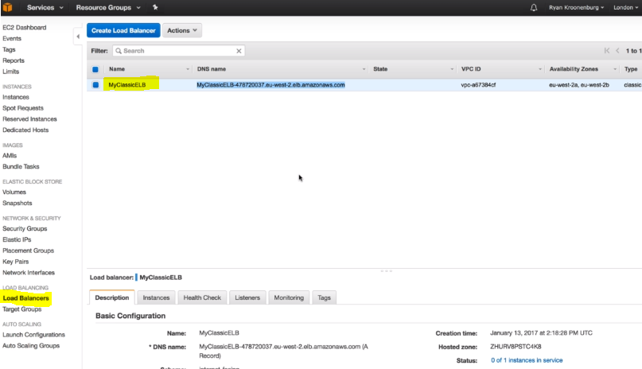

The load balancer is created.

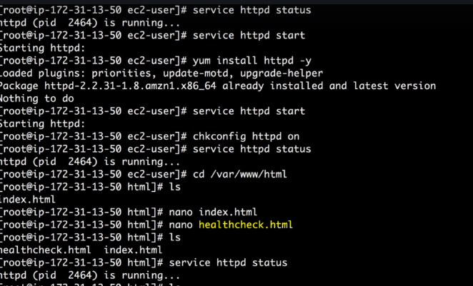

To simulate the failover, delete the html page being pinged for the health checks,

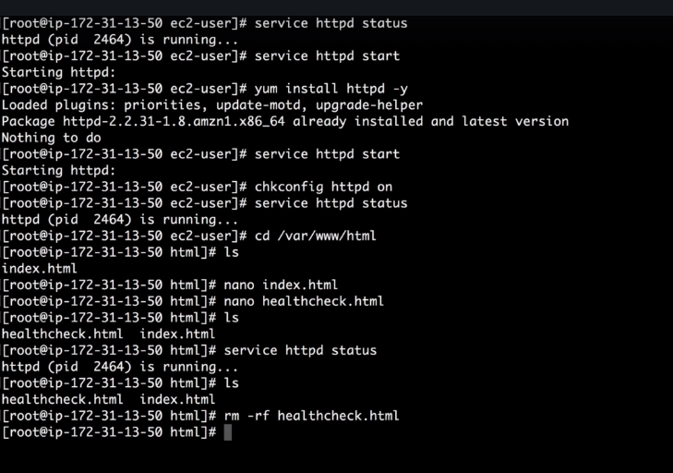

The instance will be shown as out of service,

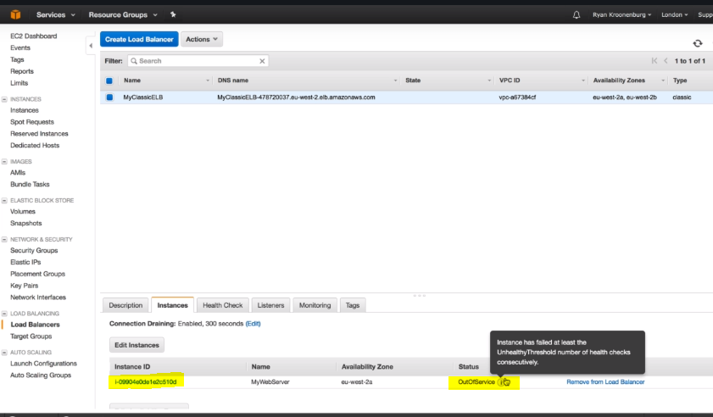

Now, recreate that file,



The instance is again back in service,

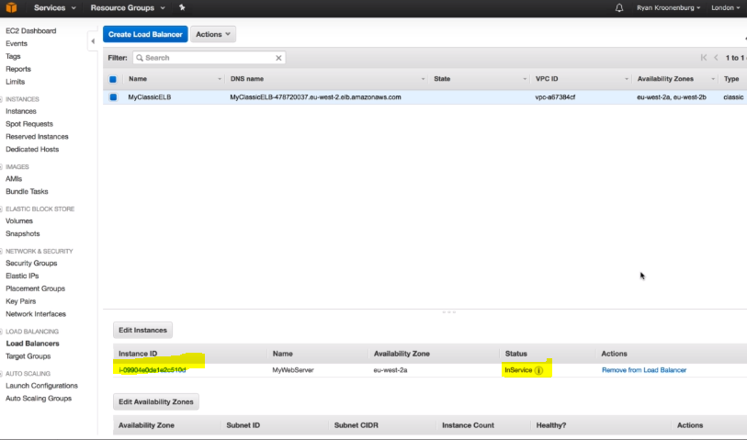

When your EC2 instance is out of service, the elastic load balancer will not send the traffic to that instance.

Copy the DNS name of your load balancer,

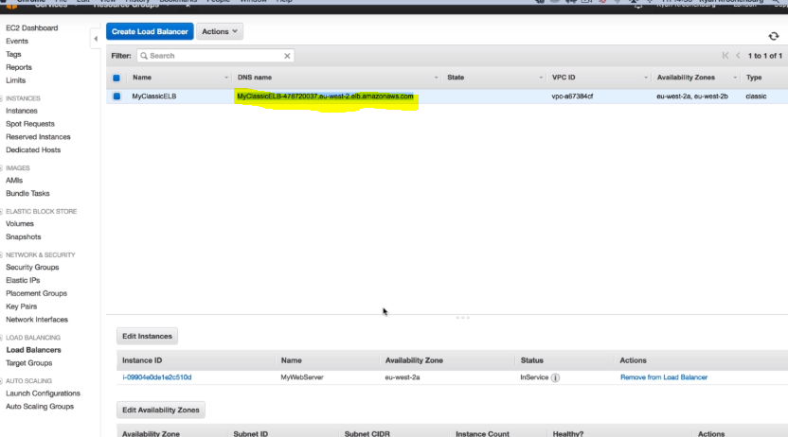

\*\* You do not get the IP address of the load address, we get only the DNS name.

When you copy the DNS name in the browser, it will resolve to the IP address of the EC2 instance and hits the index.html page.

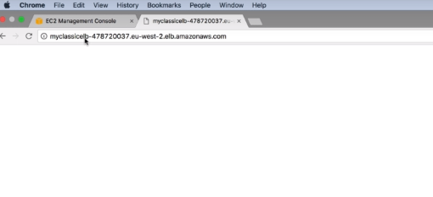

Configure Application ELB,

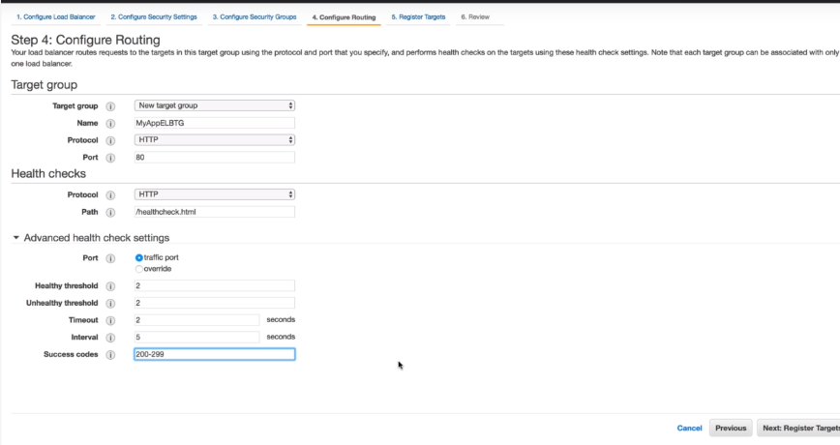

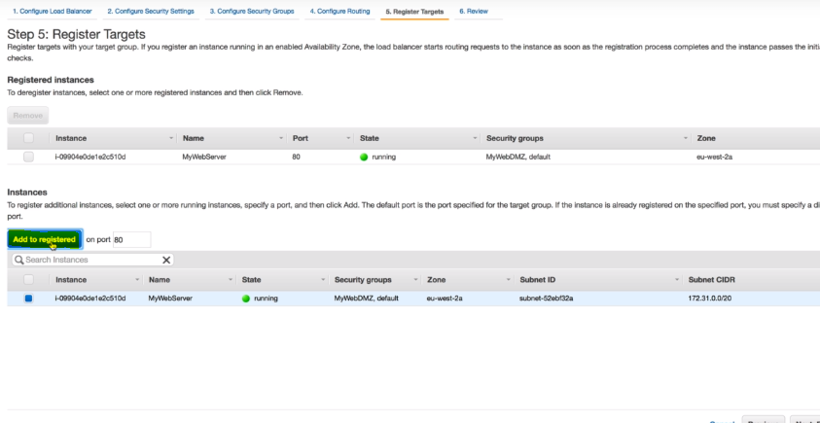

Application load balancer is also created,

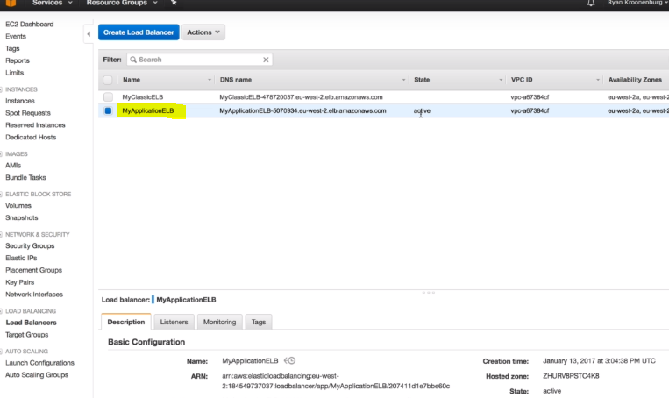

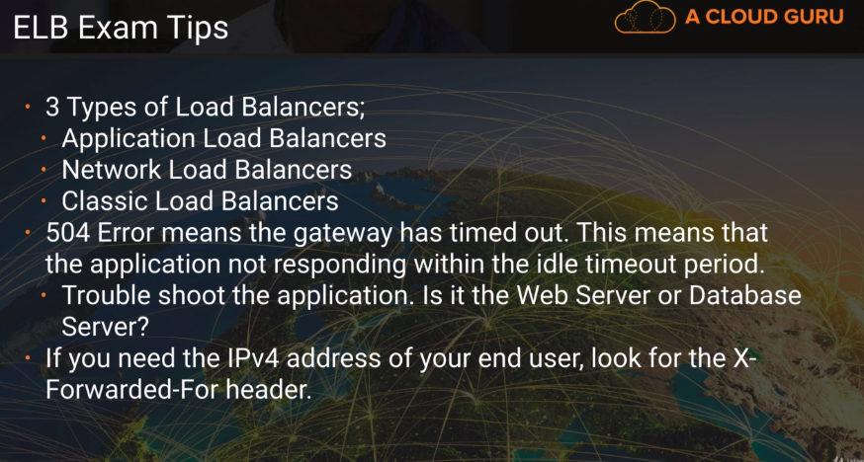

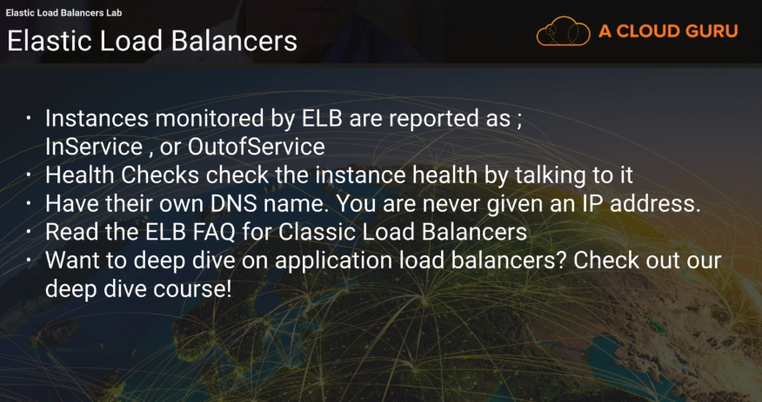

CloudWatch –

Open any running EC2 instance and see the monitoring tab. You can see that the basic monitoring is enabled which monitors the instance every 5 mins.

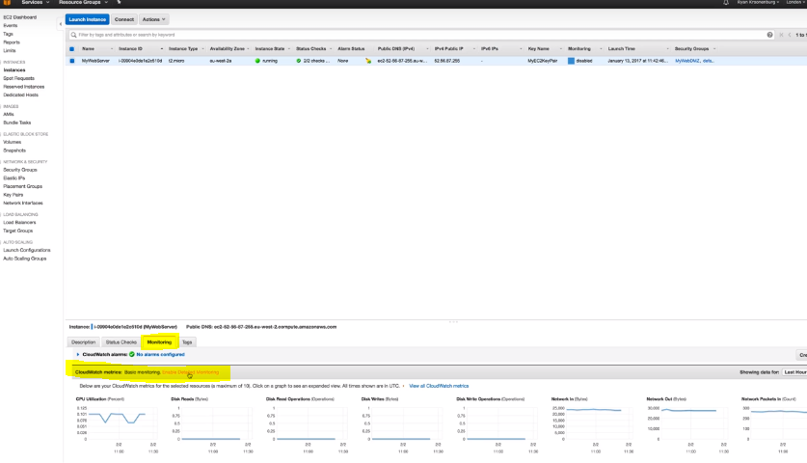

Go to cloudwatch service,

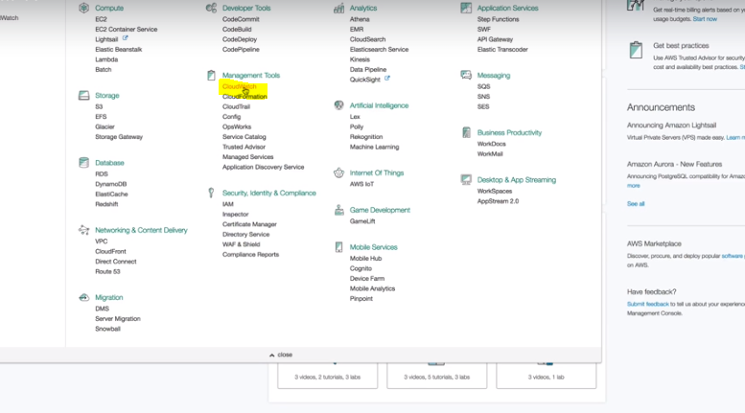

Click on dashboard and create it.

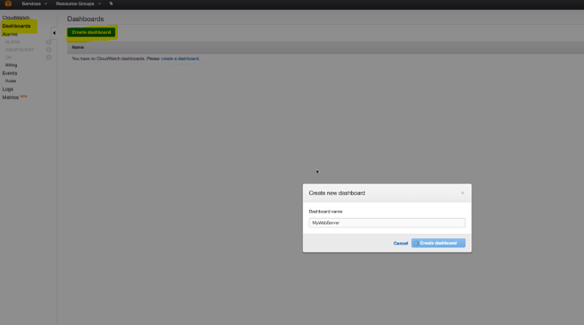

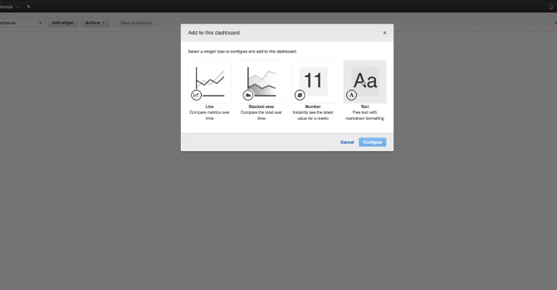

Select the text widget,

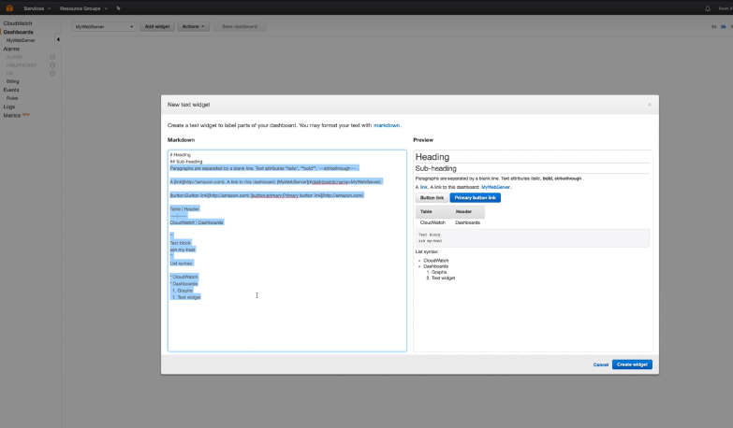

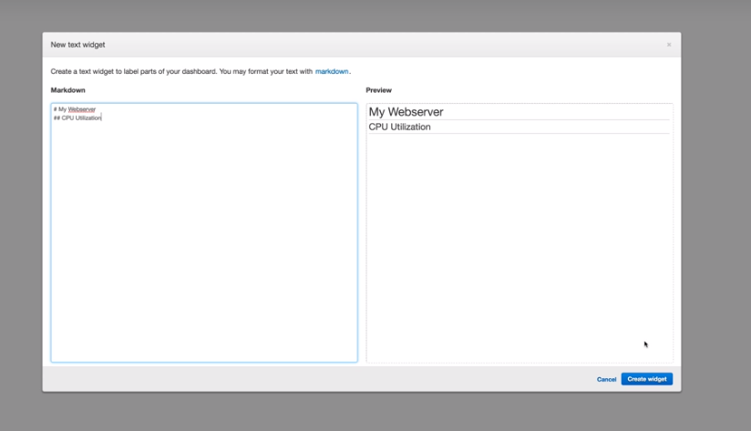

Go ahead and create,

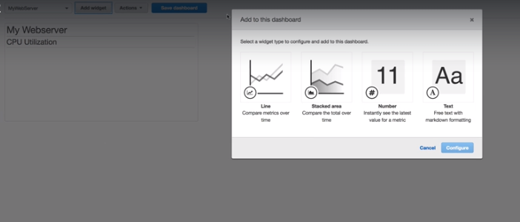

Select the line widget,

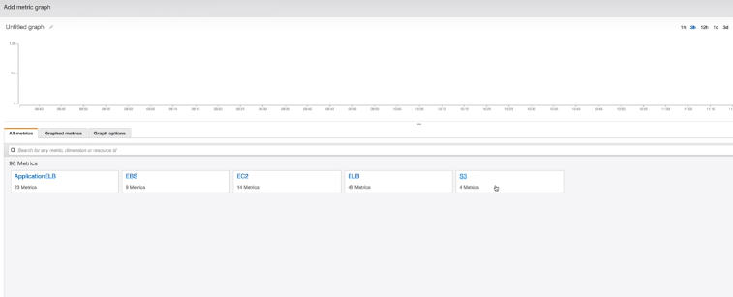

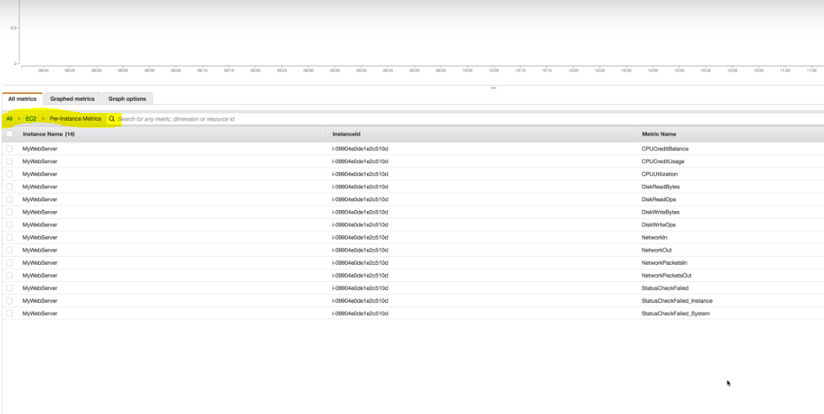

The default metrics types are-

CPU related

Status related

Disk related

Network related

Now click on CPU Utilization, to get a line graph for the same.

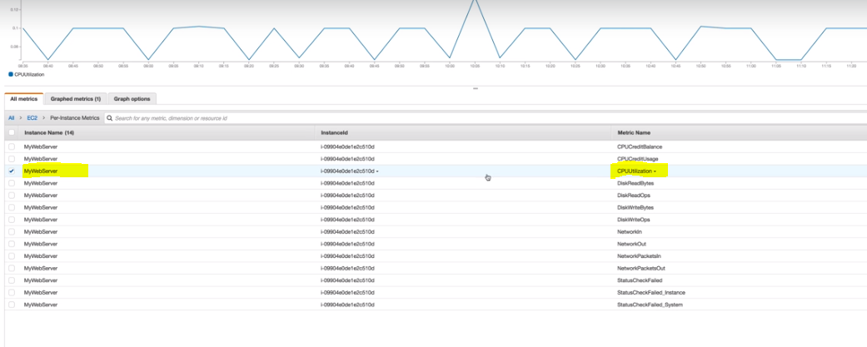

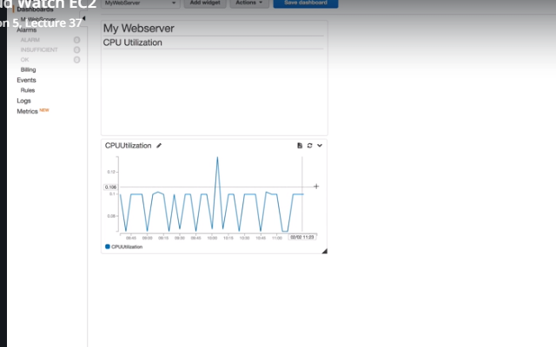

Select another widget- stacked area,

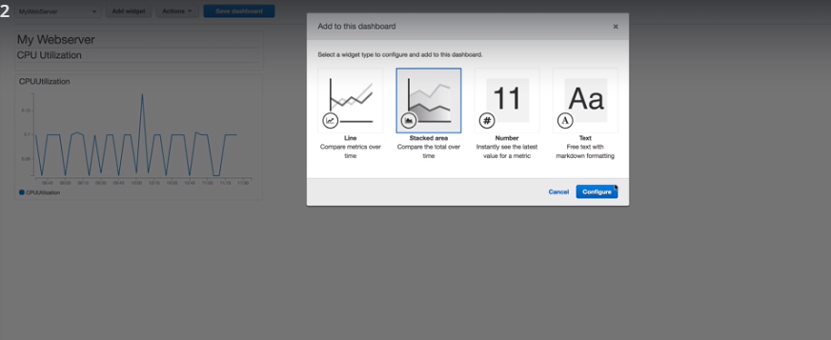

Again, click on the CUP utilization, you will get the below,

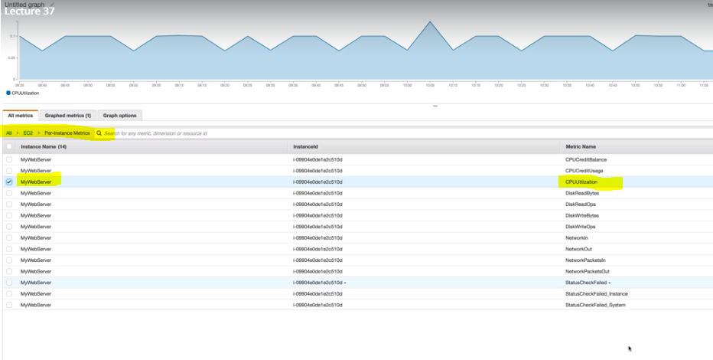

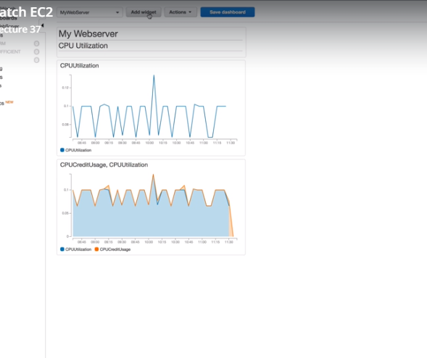

Select another widget- Number, to get the CPU Utilization as below,

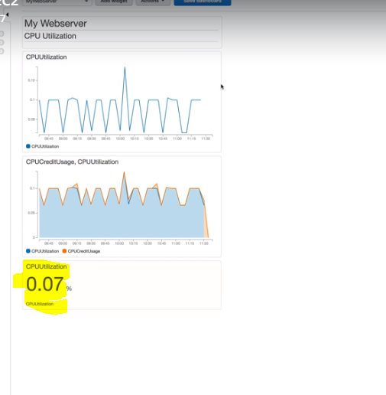

Now go to alarms,

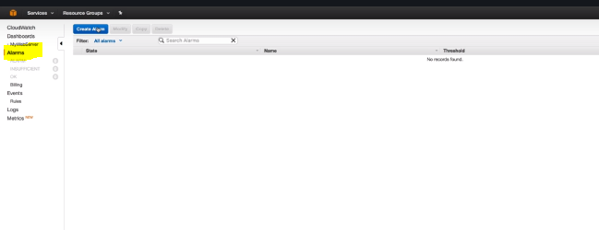

When you click on create alarm, you will get the below metrics,

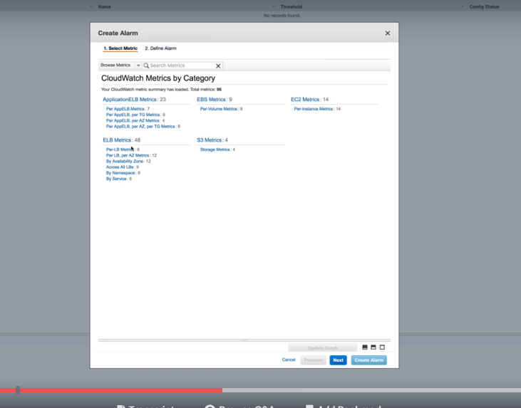

Go to Ec2 and click on CPU Utilization,

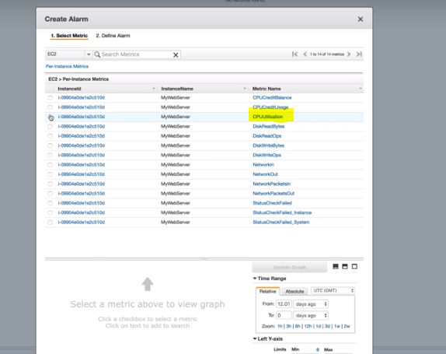

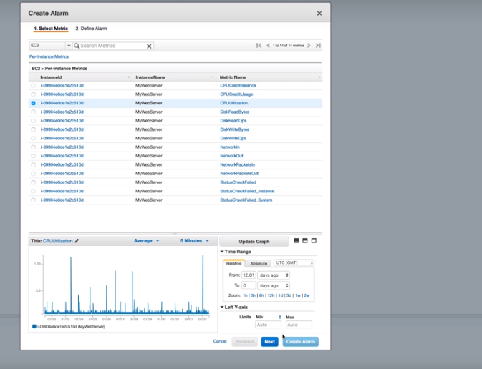

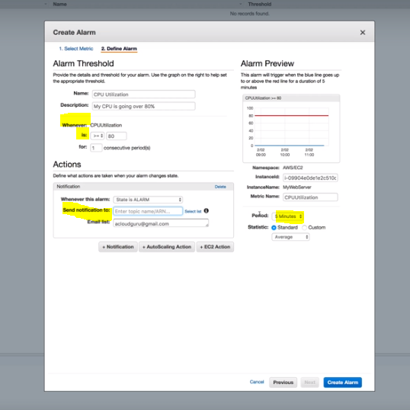

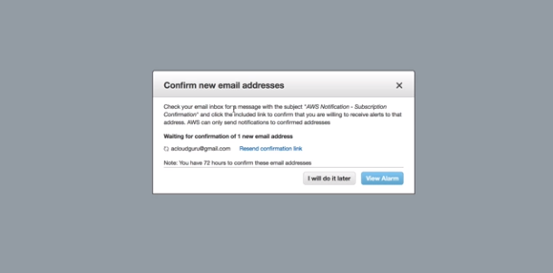

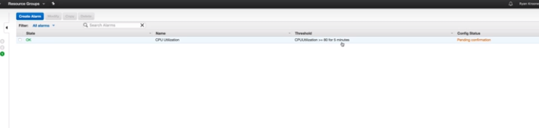

Go to the events tab,

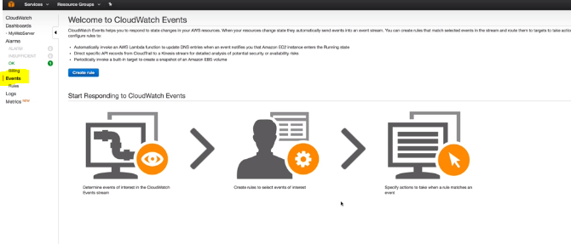

One events triggers an action. For ex, a lambda function is triggered when the state of the EC2 functions changes.

Go to the logs tab,

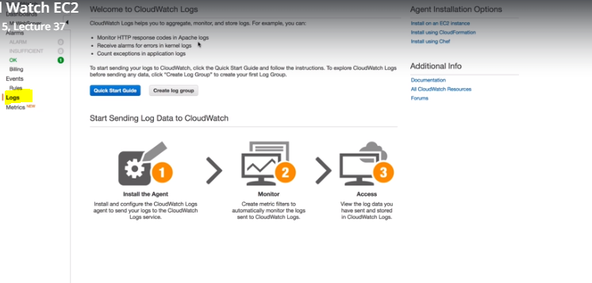

Metrics- instead of creating the dashboard with various widgets we can monitor the same using metrics.

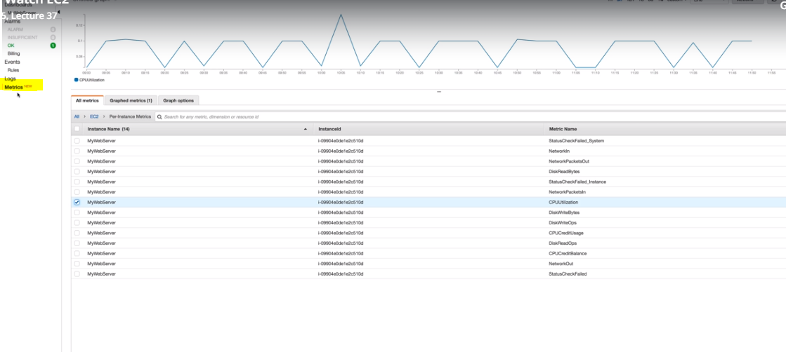

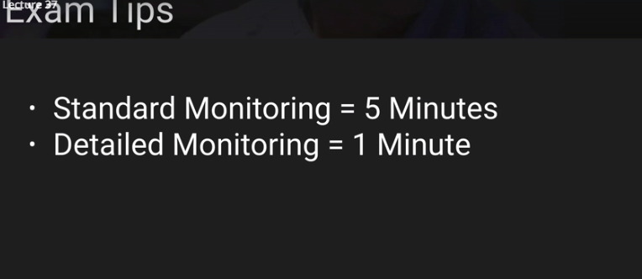

\*\* Difference between cloud watch and cloud trail

Cloud watch is used for monitoring the performamce where as cloud trail is used for auditing the entire AWS.

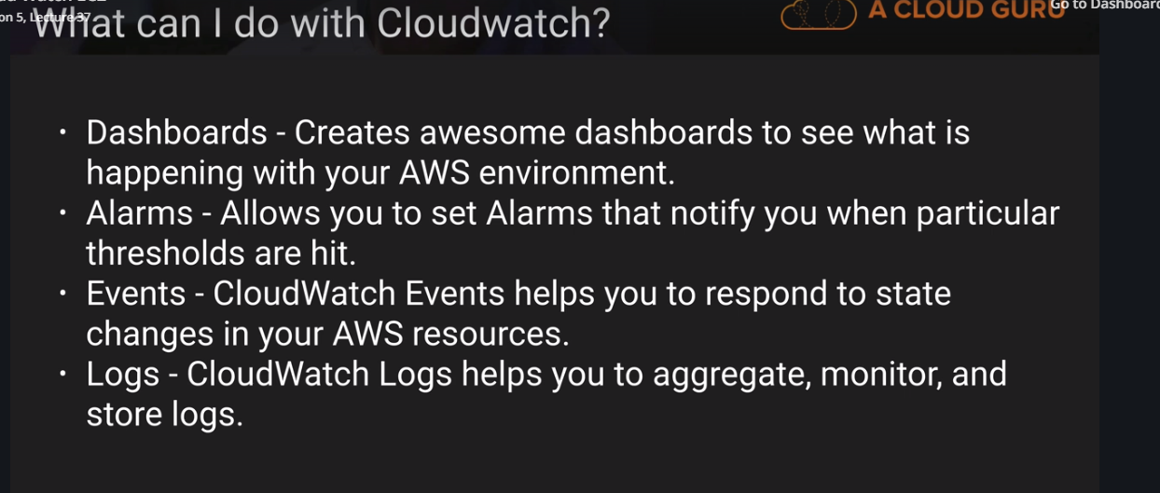

Using IAM roles with EC2-

Go to the IAM service

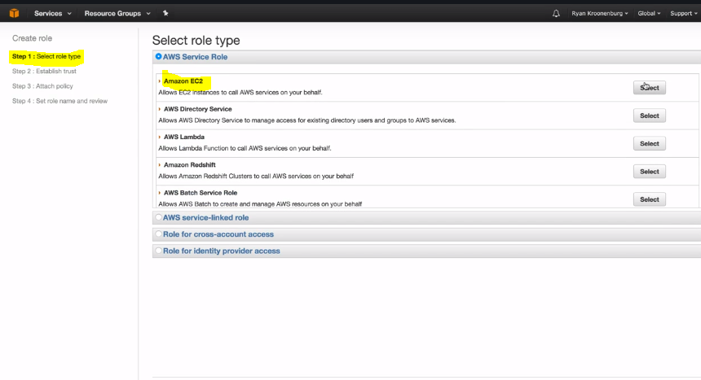

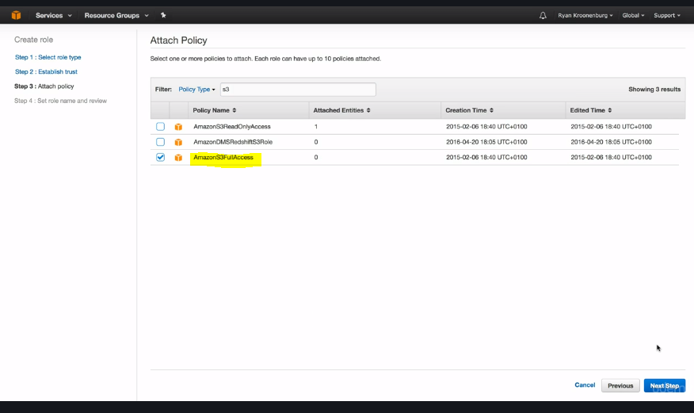

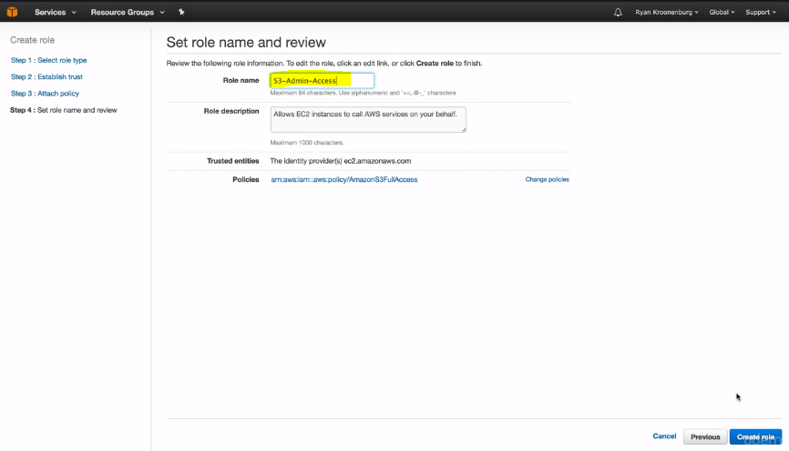

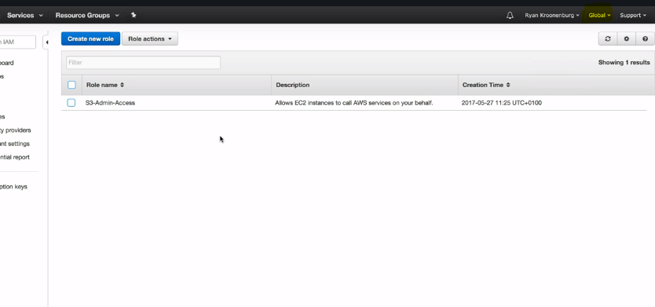

\*\*Whenever you create role it will be global, you cannot change its region.

Create an EC2 instance with this role,

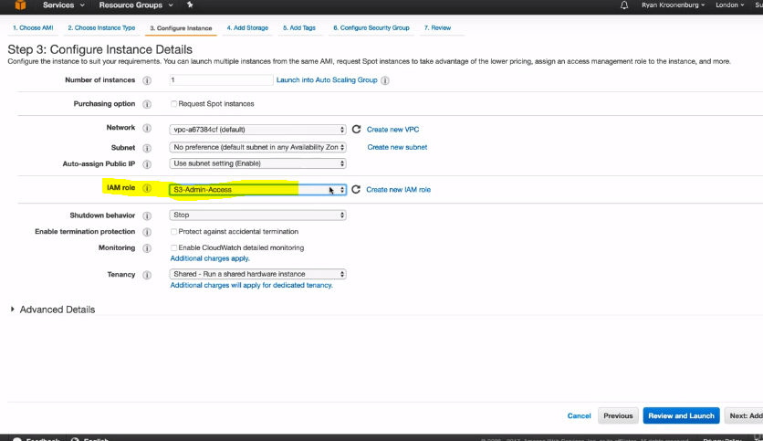

\*\*We can attach or replace iAM roles to the running instances,

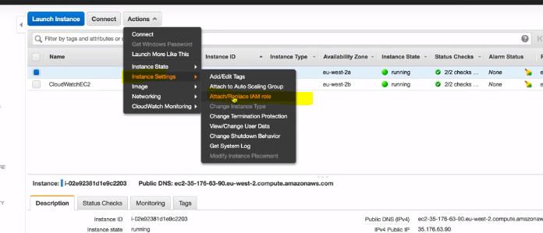

Now ssh to the created instance and type thr following command and it should work,

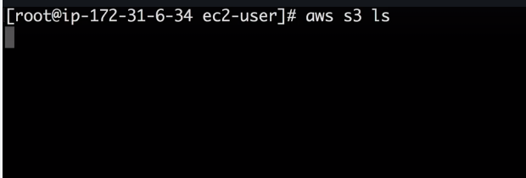

Bash scripting-

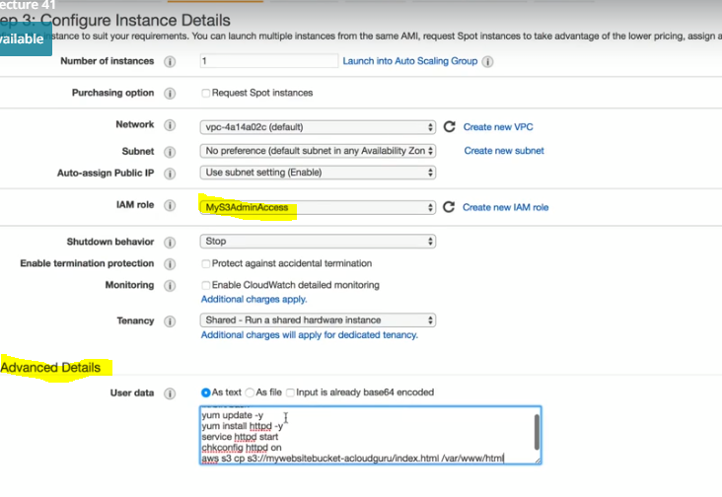

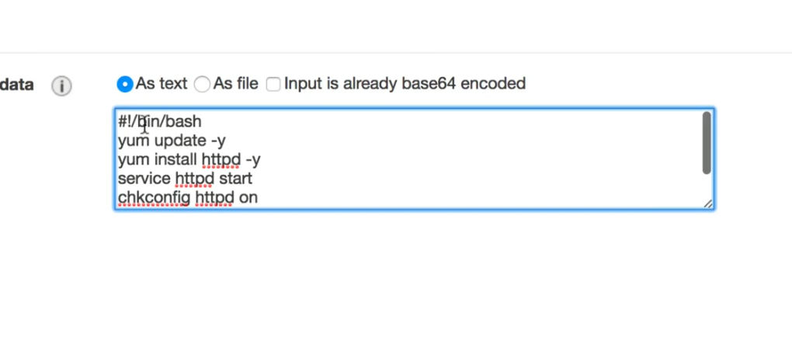

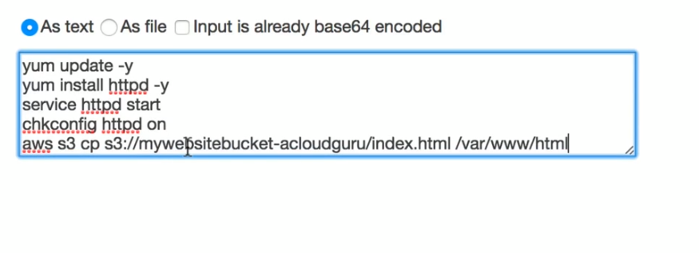

Create the instance,

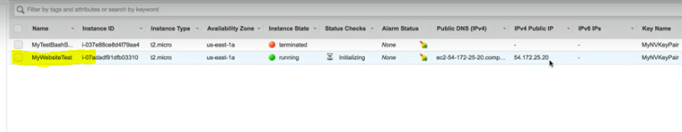

Ssh to this instance and you can see that the bucket contents are added to the /var/www/html path.

Instance metadata-

Create an EC2 instance with the below configuration,

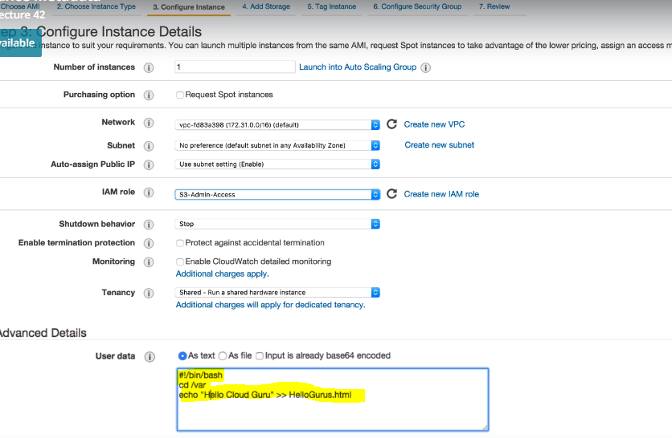

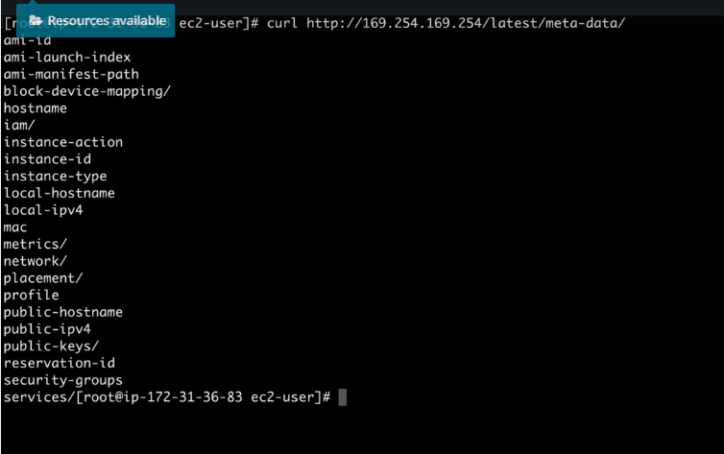



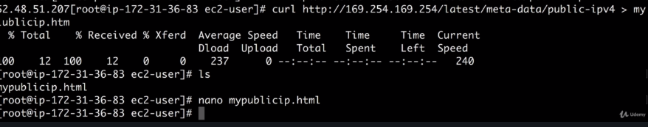

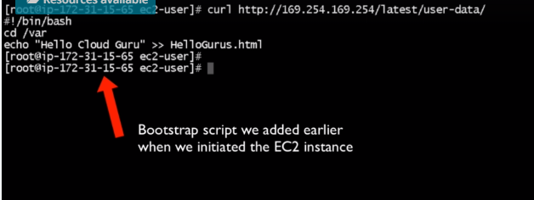

Launch Configuration and AutoScaling Groups-

Create a word document- healthcheck.html

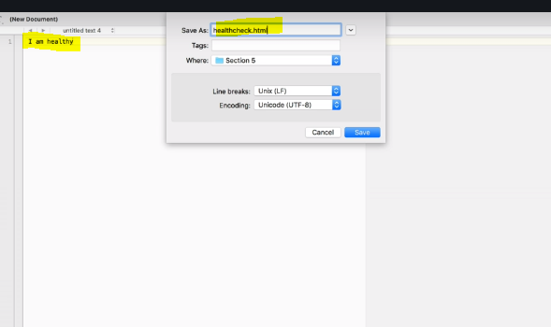

Create a S3 bucket which has both index.html and healthcheck.html,

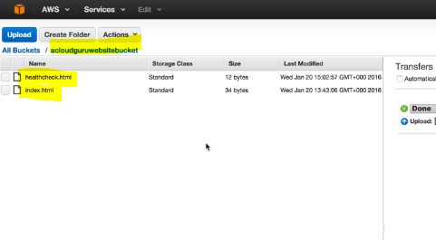

Create a Load Balancer from the EC2 service,

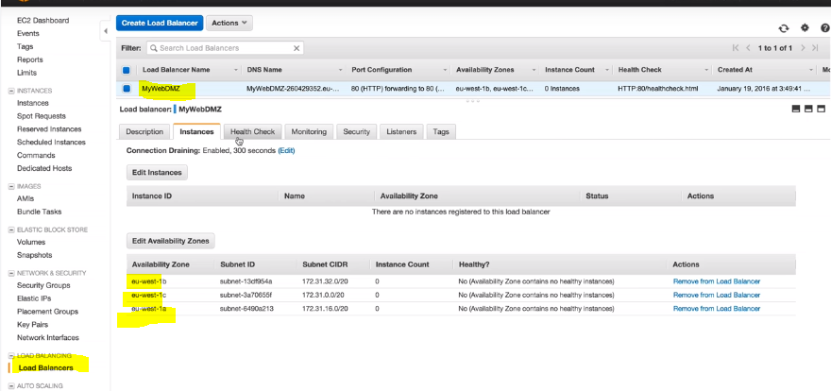

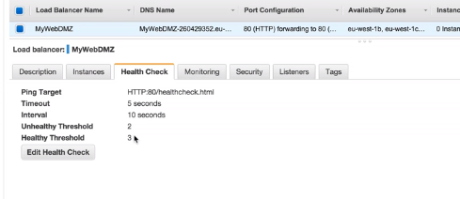

Go to Launch configuration on EC2 under Autoscaling,

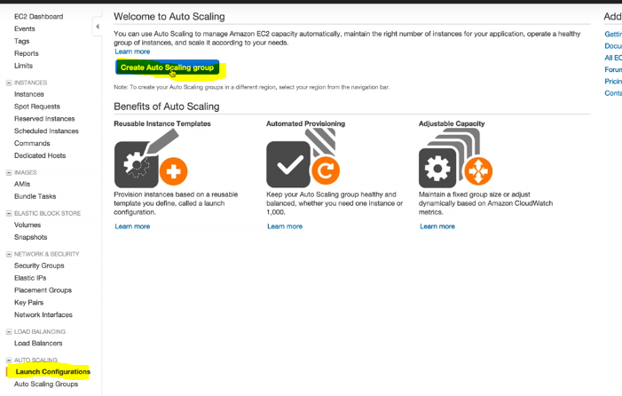

Before creating Autoscaling, you need to create Launch Configuration which is similar to instance creation,

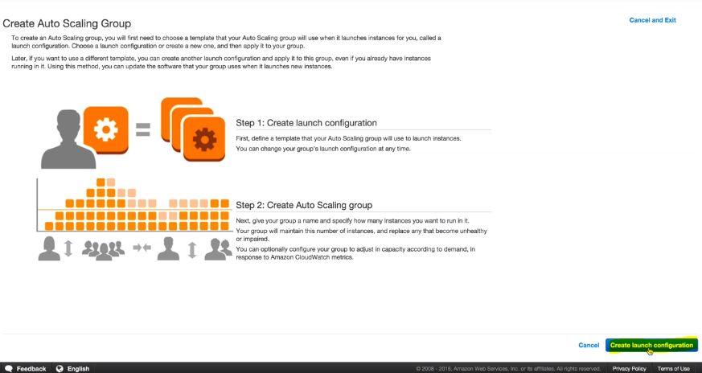

Select the ami,

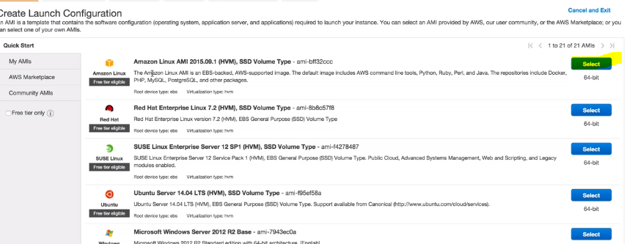

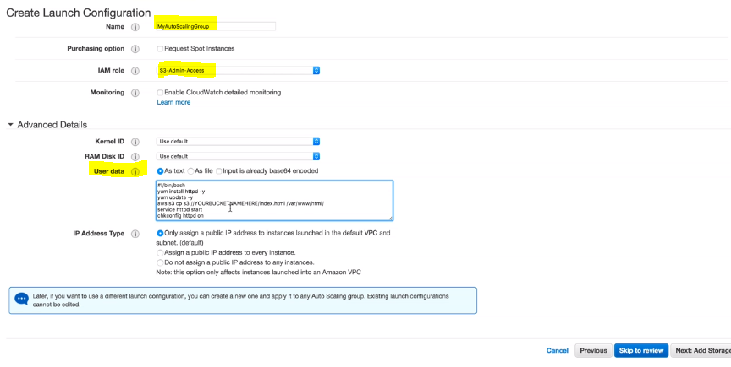

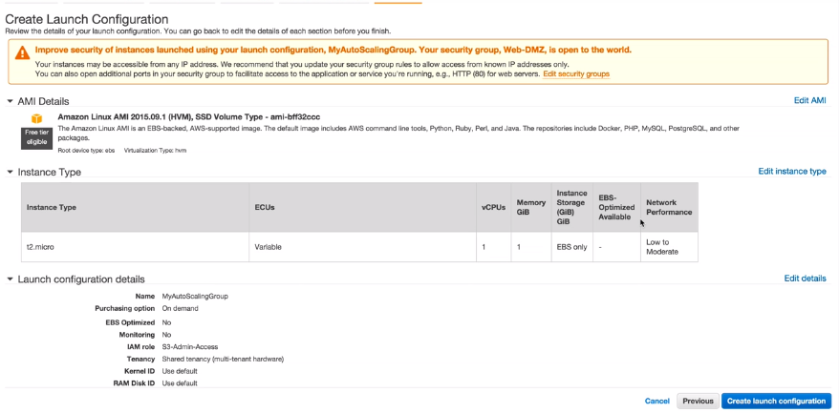

When you click on create launch instance, it will take you to the Auto scaling page,

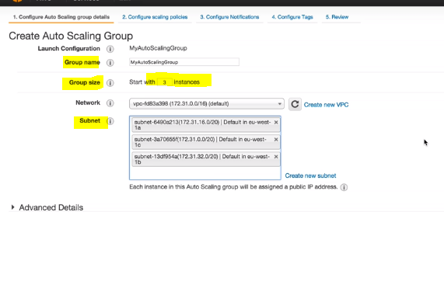

We have given group soze of 3 instances and selects all the subnets available for creating greater redundancy.

Here, Auto sacaling will automatically place the 3 different Instances in 3 different AZs.

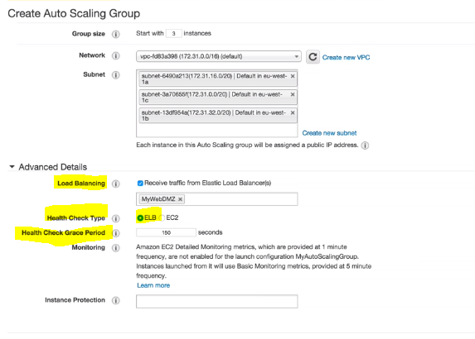

We will have to give the load balancer name which we have already created for doing the health checks.

Create an alarm for CPU Utilization,

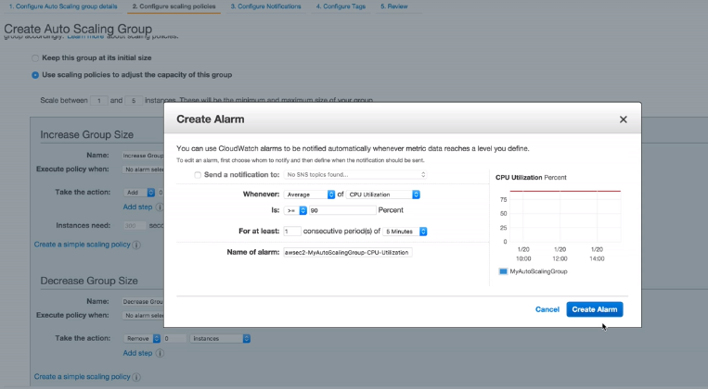

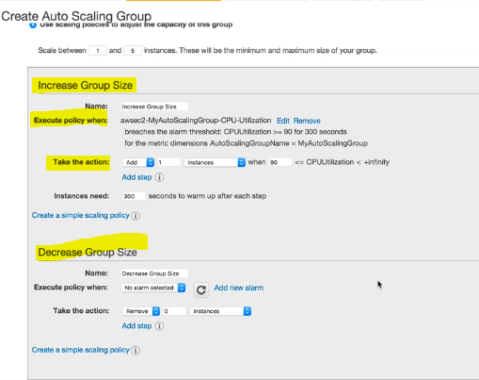

If the CPU utilization is greater than 90%, in the take actions step we can add 1 more instance.

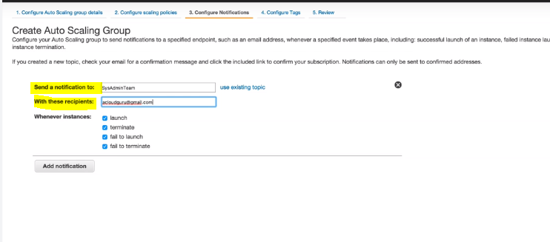

The autoscaling group is created.

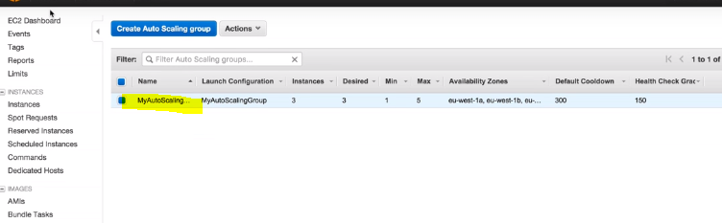

Now when you go to the EC2 dashboard, you can see that the 3 instances are being launched,

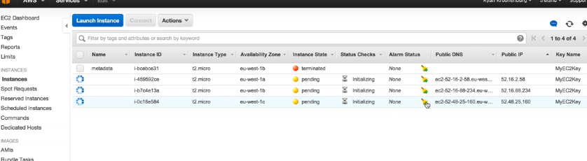

When the instances are launched successfully, you can brose to their IP address and see if they are working fine.

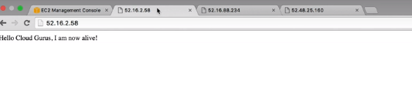

We can also go to the ELB and grab the DNS name and hit it, it will be going to one of the 3 instances.

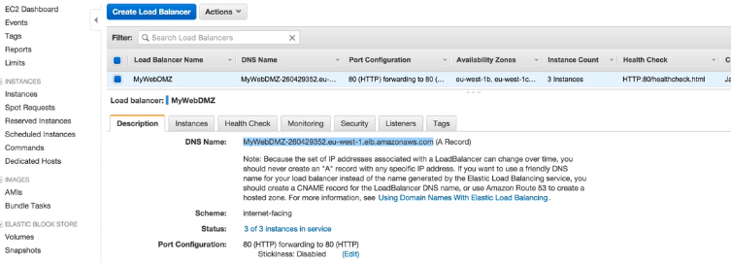

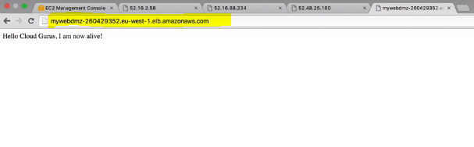

Now, to simulate AZ failure, we will terminate 2 instances and just keep one.

Now when we refresh the web browser we will get the timeout for the terminated instances. The running instances is connecting successfully. But the DNS name will resolve to the IP address of the running instance. This happens due to the health checks associated with it.

When you go to the created ELB, we can see it clearly shows that only one instance is in service.

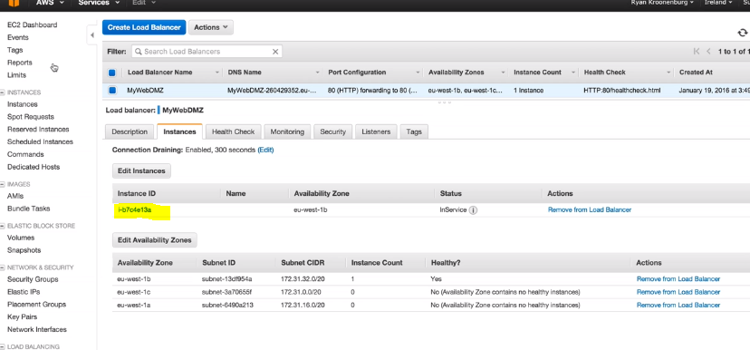

Now, when we check the Instances, we can see that the auto scaling has realized that there is some issue the instances. So, it starts provisioning new instances,

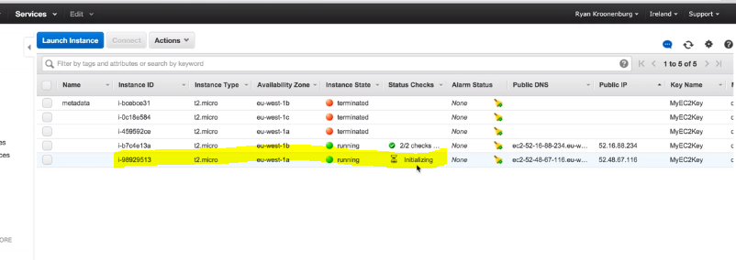

\*\* route53- If the region goes down, it will divert the traffic to the other regions.

\*\*Auto scaling – If the AZ goes down, it will divert the traffic to the other AZ.